LIBRARY MANAGEMENT SYSTEM
A DBMS Capstone Project Report submitted in partial fulfillment of the requirements for the award of the degree of
BACHELOR OF TECHNOLOGY
in
ARTIFICIAL INTELLIGENCE AND MACHINE LEARNING

Submitted By
A V S SUPRITHA – 25B11AI071
G V V RAMANA – 25B11AI370
K ANUSHKA – 25B11AI535
R NAVYA – 25B11AIA38

Under the esteemed guidance of
Mr. T.Srinivasulu M.Tech, (Ph.D.)
Assistant Professor



DEPARTMENT OF ARTIFICIAL INTELLIGENCE AND MACHINE LEARNING
ADITYA UNIVERSITY
(Formerly Aditya Engineering College (A))
Aditya Nagar, ADB Road, Surampalem, Andhra Pradesh, India
2026 – 2027

Aditya Nagar, ADB Road, Surampalem, Andhra Pradesh, India
DEPARTMENT OF ARTIFICIAL INTELLIGENCE AND MACHINE LEARNING
CERTIFICATE
This is to certify that the DBMS Capstone Project report entitled “Library Management System” is being submitted by A.V.S.Supritha (25B11AI071), G.V.V.Ramana (25B11AI370), K.Anushka (25B11AI535) and R.Navya (25B11AIA38) in partial fulfillment of the requirements for the award of the B.Tech. degree in Artificial Intelligence and Machine Learning. The work documented in this report was carried out as part of the Capstone Project for the course Database Management Systems (2501IT05) during the academic year 2026–2027, and records the database design, implementation, and documentation undertaken by the team.

Project Guide Head of the Department
Mr. T. Srinivasulu, M. Tech, (Ph.D.) Dr. K. Naga Bhargavi, M. Tech, Ph.D. Assistant professor Associate Professor & HOD

External Examiner

DECLARATION
We hereby declare that the DBMS Capstone Project entitled “Library Management System” is a genuine work carried out by us. The database design, SQL implementation, queries and documentation presented in this report are our own work, completed under the guidance of Mr. T. Srinivasulu, Department of Artificial Intelligence and Machine Learning, Aditya University, Surampalem. We further declare that this work has not been submitted, in full or in part, for the award of any degree of this or any other educational institution.

Project Associates
A.V.S.Supritha (25B11AI071)
G.V.V.Ramana (25B11AI370)
K.Anushka (25B11AI535)
R.Navya (25B11AIA38)

Date: 27 – 09 – 2026
Place: Surampalem

ACKNOWLEDGEMENT
It is with immense pleasure that we express our indebted gratitude to our project guide Mr. T. Srinivasulu, Department of Artificial Intelligence and Machine Learning, who guided us throughout the capstone project. We are thankful for the constant encouragement and valuable suggestions received at every review stage.
We are grateful to Dr. K. Naga Bhargavi, Head of the Department, for inspiring us and for arranging the facilities and resources needed for this project.
We extend our sincere thanks to the Management, Dr. M. Sreenivasa Reddy, Deputy Pro-Chancellor, Dr. M. B. Srinivas, Vice-Chancellor, and Dr. A. Ramesh, Pro Vice-Chancellor (Engineering & Sciences), for providing an excellent academic environment.
Not to forget, we thank the Teaching and Non-Teaching Staff, our parents and our friends, who have directly or indirectly supported us in completing this project on time.

Project Associates
A.V.S.Supritha 25B11AI071
G.V.V.Ramana 25B11AI370
K.Anushka 25B11AI535
R.Navya 25B11AIA38

ABSTRACT
The Library Management System is a database-based application designed to manage the daily activities of a library efficiently. The system maintains information about books, members, librarians, authors, publishers, categories, and book transactions.
It supports important operations such as adding books, registering members, issuing books, returning books, tracking due dates, and checking book availability. A relational database is used to store and organize the information systematically.
The system reduces manual work, avoids duplicate records, improves data accuracy, and makes it easier to retrieve and manage library information. Primary keys and foreign keys are used to maintain relationships between different tables and ensure data consistency.

INDEX
Chapter | Title | Page No.
 | Certificate | 2
 | Declaration | 3
 | Acknowledgement | 4
 | Abstract | 5
 | List of Figures | 8
 | List of Tables | 8
1 | Introduction | 9
 | 1.1 Introduction to the Domain | 9
 | 1.2 Problem Statement | 9
 | 1.3 Motivation and Need for a Database | 10
 | 1.4 Objectives of the Project | 10
 | 1.5 Scope of the Project | 10
 | 1.6 Organization of the Report | 10
2 | System Study and Tools | 11
 | 2.1 Existing System and Its Limitations | 11
 | 2.2 Proposed Database System | 11
 | 2.3 Tools and Technologies Used | 11
 | 2.4 Software and Hardware Requirements | 11
3 | Database Design (Review – I) | 12
 | 3.1 Identified Entities | 12
 | 3.2 Entity Attributes and Attribute Types | 12
 | 3.3 ER Diagram | 13
 | 3.4 Relationships and Cardinality | 13
 | 3.5 Relational Database Schema | 14
 | 3.6 Primary Keys and Foreign Keys | 15
 | 3.7 Normalization up to 3NF | 16
4 | Database Implementation (Review – II) | 17
 | 4.1 Database and Table Creation – DDL | 17
 | 4.2 Sample Data Insertion – DML | 23
 | 4.3 Constraints and Data Integrity | 25
 | 4.4 Data Validation Rules | 30
5 | SQL Operations and Queries | 31
 | 5.1 DQL – Basic Retrieval Queries | 31
 | 5.2 Join Operations | 32
 | 5.3 Aggregate Functions, GROUP BY and HAVING | 33
 | 5.4 Nested and Correlated Subqueries | 34
 | 5.5 Views and Relational Set Operations | 35
 | 5.6 DCL and TCL Operations | 36
6 | Modules and Functionalities | 37
7 | Results – Sample Outputs and Screenshots | 39
8 | Testing and Data Validation | 41
9 | GitHub Repository and Team Contribution | 42
10 | Conclusion and Future Enhancements | 43
 | References | 44
 | Appendix A – Complete SQL Script | 45

LIST OF FIGURES
Figure No. | Title of the Figure | Page No.
3.1 | ER Diagram of the Library Management System | 13
3.2 | Relational Schema Diagram of the Library Management System | 15
4.1 | Successful Creation of Database Tables | 20
4.2 | Sample Data Inserted into the Tables | 24
4.3 | Referential Integrity Constraint Validation | 30
7.1 | Database and Table Creation Output | 39
7.2 | Book Table Sample Records | 39
7.3 | Book, Category and Publisher JOIN Query Output | 40
7.4 | Loan Report / Aggregate Query Output | 40

LIST OF TABLES
Table No. | Title of the Table | Page No.
2.1 | Tools and Technologies Used | 11
2.2 | Software and Hardware Requirements | 11
3.1 | Entities Identified for the Library Management System | 12
3.2 | Attributes of Each Entity | 12
3.3 | Relationships and Cardinality | 13
3.4 | Relational Database Schema | 14
3.5 | Primary Key and Foreign Key Definitions | 15
3.6 | Normalization Steps | 16
4.1 | Sample Data Summary | 23
4.2 | Constraints and Data Integrity Rules | 25
5.1 | Basic Retrieval Queries | 31
5.2 | Join Operations | 32
5.3 | Aggregate, GROUP BY and HAVING Queries | 33
5.4 | Nested and Correlated Subqueries | 34
5.5 | Views and Set Operations | 35
5.6 | DCL and TCL Operations | 36
6.1 |  | 37
  Modules and Their Functionalities
8.1 | Test Cases and Results | 41
9.1 | Team Responsibilities | 42
9.2 | Review-wise Progress Record | 42

CHAPTER 1: INTRODUCTION

1.1 Introduction to the Domain
A library manages a large amount of information about books, members, authors, publishers, categories, librarians and transactions. The Library Management System provides a centralized relational database for storing and managing this information. It supports book records, member registration, issue and return activities, due dates and book availability.
The project divides information into related tables and connects them using primary and foreign keys. This structure makes data management easier, faster and more reliable while reducing duplicate records and improving consistency.


1.2 Problem Statement
Traditional library record management may rely on registers or separate files. Such approaches can make it time-consuming to find books, track availability, maintain member records, identify overdue books and preserve issue/return history. The proposed database system addresses these problems through centralized storage, relationships and integrity constraints.

1.3 Motivation and Need for a Database
A DBMS is required because library data contains multiple related entities and transactions. A relational database provides structured storage, controlled access, integrity constraints and SQL-based retrieval. Compared with disconnected spreadsheets or manual registers, it supports relationships, avoids unnecessary duplication and allows reports to be generated from consistent records.

1.4 Objectives of the Project
- To design a normalized relational database for the selected domain with at least six entities.
- To implement the database with appropriate primary keys, foreign keys and integrity constraints.
- To maintain accurate book, member, author, publisher, category, librarian and loan records.
- To demonstrate DDL, DML, DQL, joins, aggregates, subqueries, views and transaction/control operations.
- To provide query-based retrieval and reporting for library activities.

1.5 Scope of the Project
The database covers book, member, librarian, author, category, publisher and loan information, including issue, due and return dates. It supports database-level storage, retrieval, updates, deletion, reporting queries and integrity validation. The present work does not implement a complete production web application, online payment, automated fine collection or enterprise-scale authentication; these are future enhancements.

1.6 Organization of the Report
This report is organized into ten chapters. Chapter 2 presents the system study and the tools used. Chapter 3 covers the complete database design including the ER diagram, relational schema and normalization. Chapter 4 describes the database implementation with DDL and sample data. Chapter 5 presents the SQL operations and queries executed. Chapter 6 explains the modules and functionalities. Chapter 7 presents the results with sample outputs. Chapter 8 covers testing and data validation. Chapter 9 details the GitHub repository and the contribution of each team member. Chapter 10 concludes the report and outlines future enhancements.

CHAPTER 2: SYSTEM STUDY AND TOOLS

2.1 Existing System and Its Limitations
In a traditional library environment, records may be maintained manually using registers or separate files. This can result in time-consuming searches, duplicate records, difficulty tracking availability and overdue books, and inconsistent issue/return information.

2.2 Proposed Database System
The proposed Library Management System uses a relational database with separate tables for books, members, librarians, authors, categories, publishers, loans and the Book_Author relationship. Primary and foreign keys connect the tables, while constraints protect data integrity. SQL queries provide retrieval, reporting and analysis.

2.3 Tools and Technologies Used
Table 2.1: Tools and Technologies Used
Category | Tool / Technology Used | Version / Remarks
Database Server | MySQL | Relational DBMS
Query / Admin Tool | MySQL Workbench | SQL execution and administration
ER Diagram Tool | draw.io / diagrams.net | ER and schema diagrams
Front-end | HTML, CSS | Prototype/front-end technology identified
Operating System | Windows 11 | Development environment
Version Control | GitHub | Team repository
Documentation | MS Word | Project report

2.4 Software and Hardware Requirements
Table 2.2: Software and Hardware Requirements
Requirement Type | Specification
Processor | Intel/AMD processor capable of running MySQL Workbench
RAM | Minimum 4 GB; 8 GB or more recommended
Storage | At least 10 GB free space for tools and project files
Operating System | Windows 11
Software | MySQL Server, MySQL Workbench, draw.io/diagrams.net, MS Word
Internet | Required for GitHub repository access and collaboration

CHAPTER 3: DATABASE DESIGN
(Deliverables of Review – I)

3.1 Identified Entities
Minimum six entities are required. Give a one-line description of each.
Table 3.1: Entities Identified for the Selected Domain
S.No | Entity Name | Description
1 | Book | Stores information about books.
2 | Member | Stores library member details.
3 | Librarian | Stores librarian information.
4 | Author | Stores author details.
5 | Category | Classifies books.
6 | Loan | Stores issue and return transactions.
7 | Publisher | Stores publisher information.
8 | Book_Author | Junction table connecting books and authors.

3.2 Entity Attributes and Attribute Types
List every attribute of every entity. Mark the key column as PK, FK or —, and classify each attribute as Simple, Composite, Multi-valued or Derived.
Table 3.2: Attributes of Each Entity
Entity | Attribute | Data Type | Key (PK / FK / —) | Attribute Type
Book | Book_ID | INT | PK | Simple
Book | Title | VARCHAR(100) | — | Simple
Book | ISBN | VARCHAR(20) | — | Simple
Book | Publication_Year | INT | — | Simple
Book | Copies | INT | — | Simple
Book | Category_ID | INT | FK | Simple
Book | Publisher_ID | INT | FK | Simple
Member | Member_ID | INT | PK | Simple
Member | Name | VARCHAR(100) | — | Simple
Member | Phone | VARCHAR(15) | — | Simple
Member | Email | VARCHAR(100) | — | Simple
Member | Address | VARCHAR(200) | — | Simple
Member | Join_Date | DATE | — | Simple
Librarian | Librarian_ID | INT | PK | Simple
Librarian | Name | VARCHAR(100) | — | Simple
Librarian | Phone | VARCHAR(15) | — | Simple
Librarian | Email | VARCHAR(100) | — | Simple
Author | Author_ID | INT | PK | Simple
Author | Author_Name | VARCHAR(100) | — | Simple
Category | Category_ID | INT | PK | Simple
Category | Category_Name | VARCHAR(100) | — | Simple
Publisher | Publisher_ID | INT | PK | Simple
Publisher | Publisher_Name | VARCHAR(100) | — | Simple
Publisher | Contact | VARCHAR(100) | — | Simple
Loan | Loan_ID | INT | PK | Simple
Loan | Book_ID | INT | FK | Simple
Loan | Member_ID | INT | FK | Simple
Loan | Librarian_ID | INT | FK | Simple
Loan | Issue_Date | DATE | — | Simple
Loan | Due_Date | DATE | — | Simple
Loan | Return_Date | DATE | — | Simple
Book_Author | Book_ID | INT | PK, FK | Simple
Book_Author | Author_ID | INT | PK, FK | Simple

3.3 ER Diagram
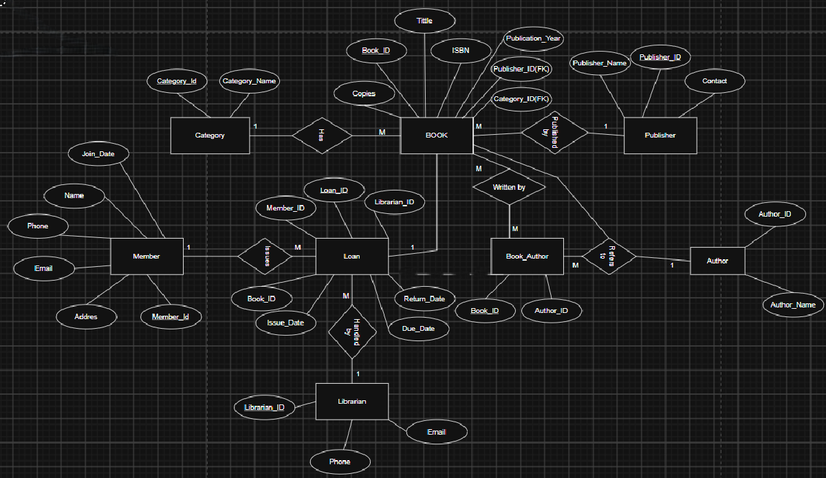

Fig. 3.1: ER Diagram of the Library Management System

3.4 Relationships and Cardinality
Table 3.3: Relationships and Cardinality
Entity 1 | Relationship | Entity 2 | Cardinality (1:1 / 1:N / M:N) | Participation
Category | Belongs To | Book | 1:N | Book participates through Category_ID
Publisher | Publishes | Book | 1:N | Book participates through Publisher_ID
Member | Borrows | Loan | 1:N | Loan requires a Member
Book | Is Issued In | Loan | 1:N | Loan requires a Book
Librarian | Processes | Loan | 1:N | Loan requires a Librarian
Book | Written By | Author | M:N | Implemented using Book_Author

3.5 Relational Database Schema
Table 3.4: Relational Database Schema
Table Name | Column Name | Data Type | Key (PK / FK / —) | Constraints
Book | Book_ID | INT | PK | Primary key, Not Null
Book | Title | VARCHAR(100) | ----- | Not Null
Book | ISBN | VARCHAR(20) | ----- | Not Null, Unique
Book | Publication_Year | INT | ----- | Check
Book | Copies | INT | ----- | Not Null, Default 1, Check
Book | Category_ID | INT | FK | Not Null, Foreign key
Book | Publisher_ID | INT | FK | Not Null, Foreign key
Member | Member_ID | INT | PK | Primary key, Not Null
Member | Name | VARCHAR(100) | ----- | Not Null
Member | Phone | VARCHAR(15) | ----- | Unique
Member | Email | VARCHAR(100) | ----- | Unique
Member | Address | VARCHAR(200) | ----- | -----
Member | Join_Date | DATE | ----- | Not Null, Default
Librarian | Librarian_ID | INT | PK | Primary key, Not Null
Librarian | Name | VARCHAR(100) | ----- | Not Null
Librarian | Phone | VARCHAR(15) | ----- | Unique
Librarian | Email | VARCHAR(100) | ----- | Unique
Author | Author_ID | INT | PK | Primary key, Not Null
Author | Author_Name | VARCHAR(100) | ----- | Not Null
Category | Category_ID | INT | PK | Primary key, Not Null
Category | Category_Name | VARCHAR(100) | ----- | Not Null, Unique
Publisher | Publisher_ID | INT | PK | Primary key, Not Null
Publisher | Publisher_Name | VARCHAR(100) | ----- | Not Null, Unique
Publisher | Contact | VARCHAR(100) | ----- | -----
Loan | Loan_ID | INT | PK | Primary Key, Not Null
Loan | Book_ID | INT | FK | Not Null, Foreign key
Loan | Member_ID | INT | FK | Not Null, Foreign key
Loan | Librarian_ID | INT | FK | Not Null, Foreign key
Loan | Issue_Date | DATE | ----- | Not Null, Default
Loan | Due_Date | DATE | ----- | Not Null, Check
Loan | Return_Date | DATE | ----- | Null, Check
Book_Author | Book_ID | INT | PK, FK | Primary key, Foreign key
Book_Author | Author_ID | INT | PL, FK | Primary key, Foreign key

Schema Diagram :
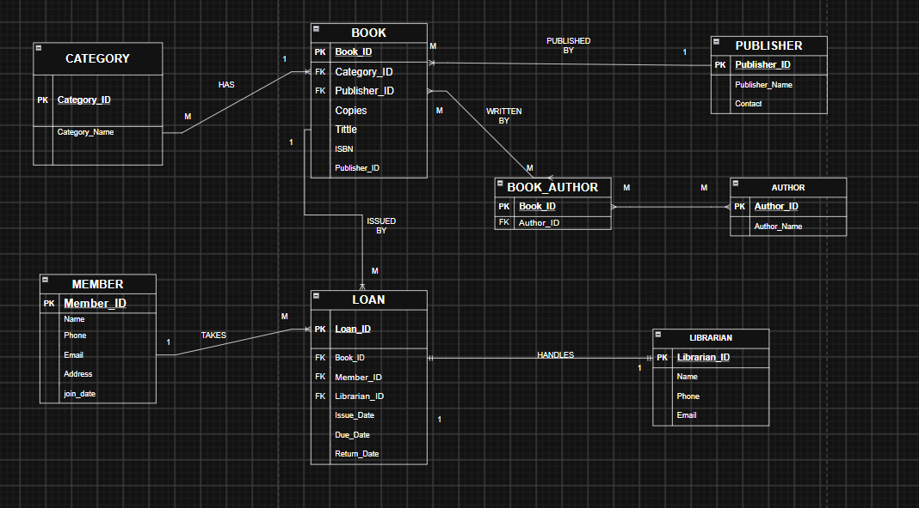

Fig. 3.2: Relational Schema Diagram

3.6 Primary Keys and Foreign Keys
Table 3.5: Primary Key and Foreign Key Definitions
Table | Primary Key | Foreign Key | References (Table.Column)
Category | Category_ID | — | —
Publisher | Publisher_ID | — | —
Author | Author_ID | — | —
Librarian | Librarian_ID | — | —
Member | Member_ID | — | —
Book | Book_ID | Category_ID; Publisher_ID | Category.Category_ID; Publisher.Publisher_ID
Book_Author | Book_ID, Author_ID | Book_ID; Author_ID | Book.Book_ID; Author.Author_ID
Loan | Loan_ID | Book_ID; Member_ID; Librarian_ID | Book.Book_ID; Member.Member_ID; Librarian.Librarian_ID

3.7 Normalization up to 3NF
UNF → 1NF → 2NF → 3NF
Table 3.6: Normalization Steps
Normal Form | Condition Satisfied | Anomaly Removed | Resulting Tables
UNF | Repeated book, author, member, publisher and loan information may exist | Repeated groups and uncontrolled redundancy | Single unnormalized library record
1NF | Each attribute contains a single value; repeating groups removed | Repeating-group anomaly | Separate Book, Member, Author, Publisher, Category, Librarian and Loan records
2NF | Partial dependencies removed from composite key | Partial update anomaly | Book_Author uses (Book_ID, Author_ID)
3NF | Transitive dependencies reduced by separating descriptive entities | Update/insert/delete anomalies | Normalized related tables connected by foreign keys

CHAPTER 4: DATABASE IMPLEMENTATION
(Deliverables of Review – II)

4.1 Database and Table Creation – DDL
CREATE TABLE Category (
Category_ID INT PRIMARY KEY,
Category_Name VARCHAR(100) NOT NULL UNIQUE
);

CREATE TABLE Publisher (
Publisher_ID INT PRIMARY KEY,
Publisher_Name VARCHAR(100) NOT NULL UNIQUE,
Contact VARCHAR(100)
);

CREATE TABLE Author (
Author_ID INT PRIMARY KEY,
Author_Name VARCHAR(100) NOT NULL
);

CREATE TABLE Librarian (
Librarian_ID INT PRIMARY KEY,
Name VARCHAR(100) NOT NULL,
Phone VARCHAR(15) UNIQUE,
Email VARCHAR(100) UNIQUE
);

CREATE TABLE Member (
Member_ID INT PRIMARY KEY,
Name VARCHAR(100) NOT NULL,
Phone VARCHAR(15) UNIQUE,
Email VARCHAR(100) UNIQUE,
Address VARCHAR(200),
Join_Date DATE NOT NULL DEFAULT CURRENT_DATE
);

CREATE TABLE Book (
Book_ID INT PRIMARY KEY,
Title VARCHAR(100) NOT NULL,
ISBN VARCHAR(20) NOT NULL UNIQUE,
Publication_Year INT CHECK (Publication_Year BETWEEN 1000 AND 2100),
Copies INT NOT NULL DEFAULT 1 CHECK (Copies >= 0),
Category_ID INT NOT NULL,
Publisher_ID INT NOT NULL,
FOREIGN KEY (Category_ID) REFERENCES Category(Category_ID),
FOREIGN KEY (Publisher_ID) REFERENCES Publisher(Publisher_ID)
);

CREATE TABLE Book_Author (
Book_ID INT NOT NULL,
Author_ID INT NOT NULL,
PRIMARY KEY (Book_ID, Author_ID),
FOREIGN KEY (Book_ID) REFERENCES Book(Book_ID),
FOREIGN KEY (Author_ID) REFERENCES Author(Author_ID)
);

CREATE TABLE Loan (
Loan_ID INT PRIMARY KEY,
Book_ID INT NOT NULL,
Member_ID INT NOT NULL,
Librarian_ID INT NOT NULL,
Issue_Date DATE NOT NULL DEFAULT CURRENT_DATE,
Due_Date DATE NOT NULL,
Return_Date DATE,
CHECK (Due_Date >= Issue_Date),
CHECK (Return_Date IS NULL OR Return_Date >= Issue_Date),
FOREIGN KEY (Book_ID) REFERENCES Book(Book_ID),
FOREIGN KEY (Member_ID) REFERENCES Member(Member_ID),
FOREIGN KEY (Librarian_ID) REFERENCES Librarian(Librarian_ID)
);

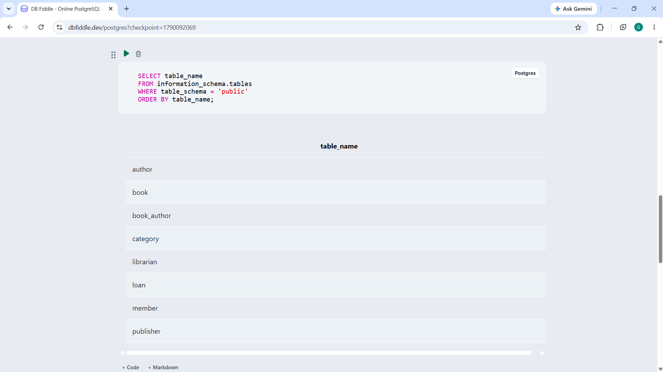

Fig. 4.1: Successful Creation of Tables

4.2 Sample Data Insertion – DML

.
S.No | Table Name | No. of Records Inserted | Screenshot Reference
1. | Category | 5 | 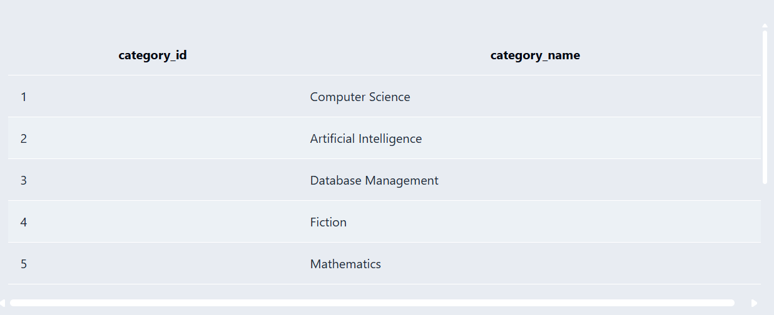
2. | Publisher | 5 | 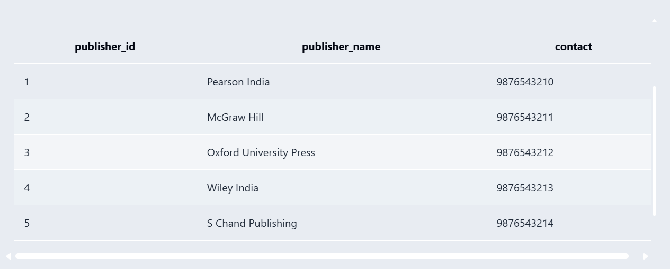
3. | Author | 5 | 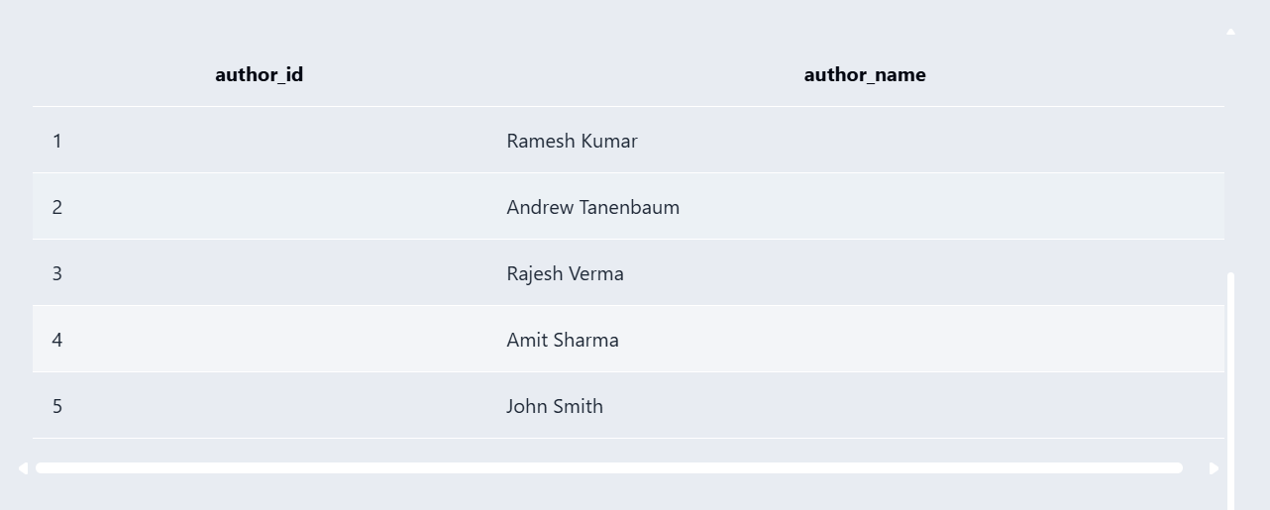
4. | Librarian | 5 | 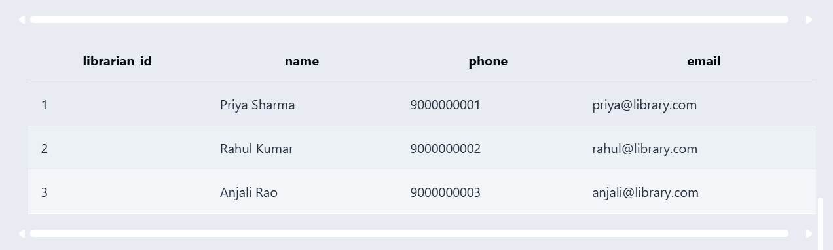
5. | Member | 5 | 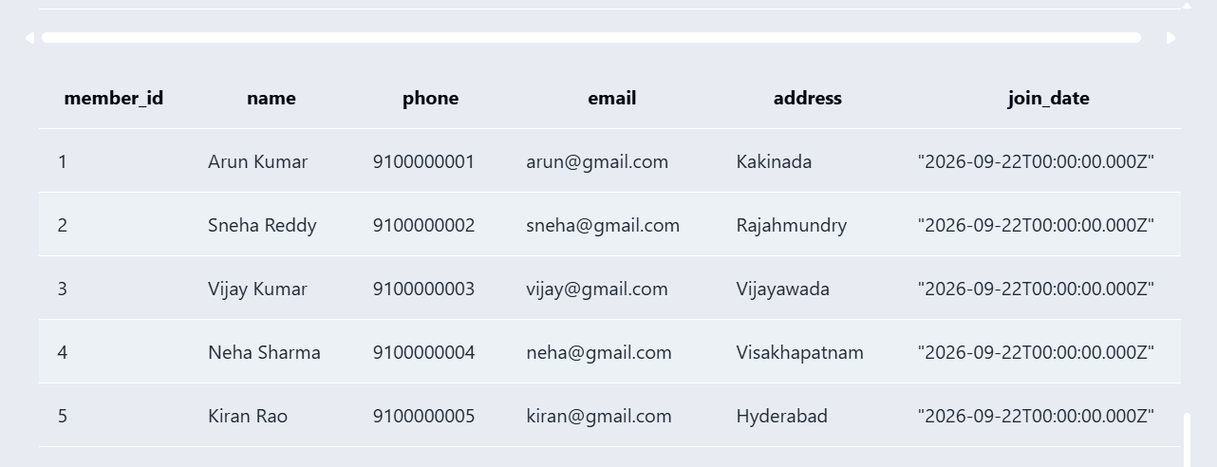
6. | Book | 5 | 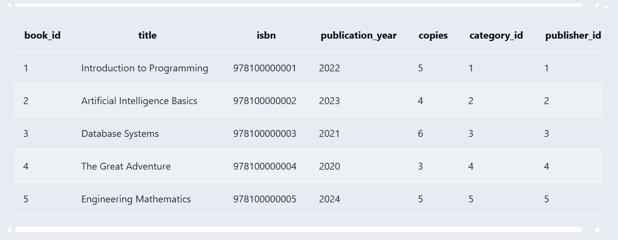
7. | Book_Author | 5 | 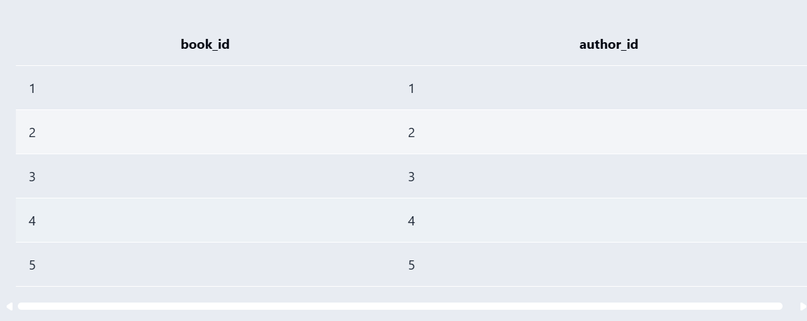
8. | Loan | 5 | 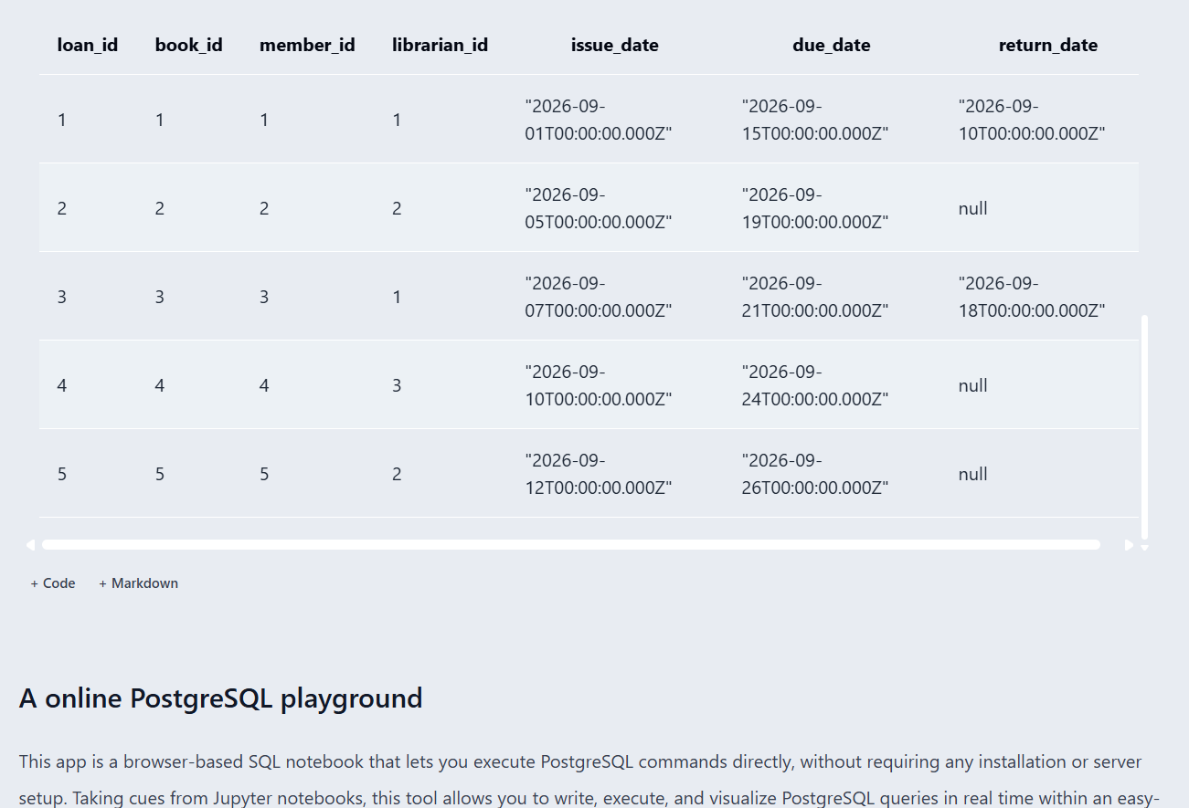
Table 4.1: Sample Data Summary

UPDATE:

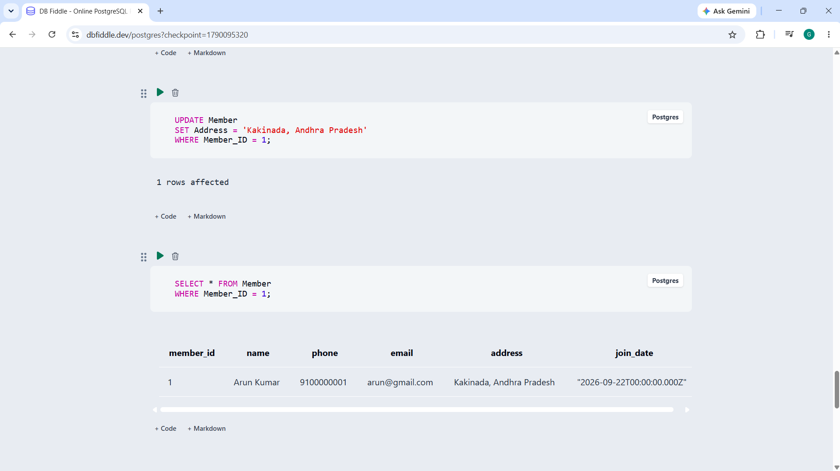

DELETE:

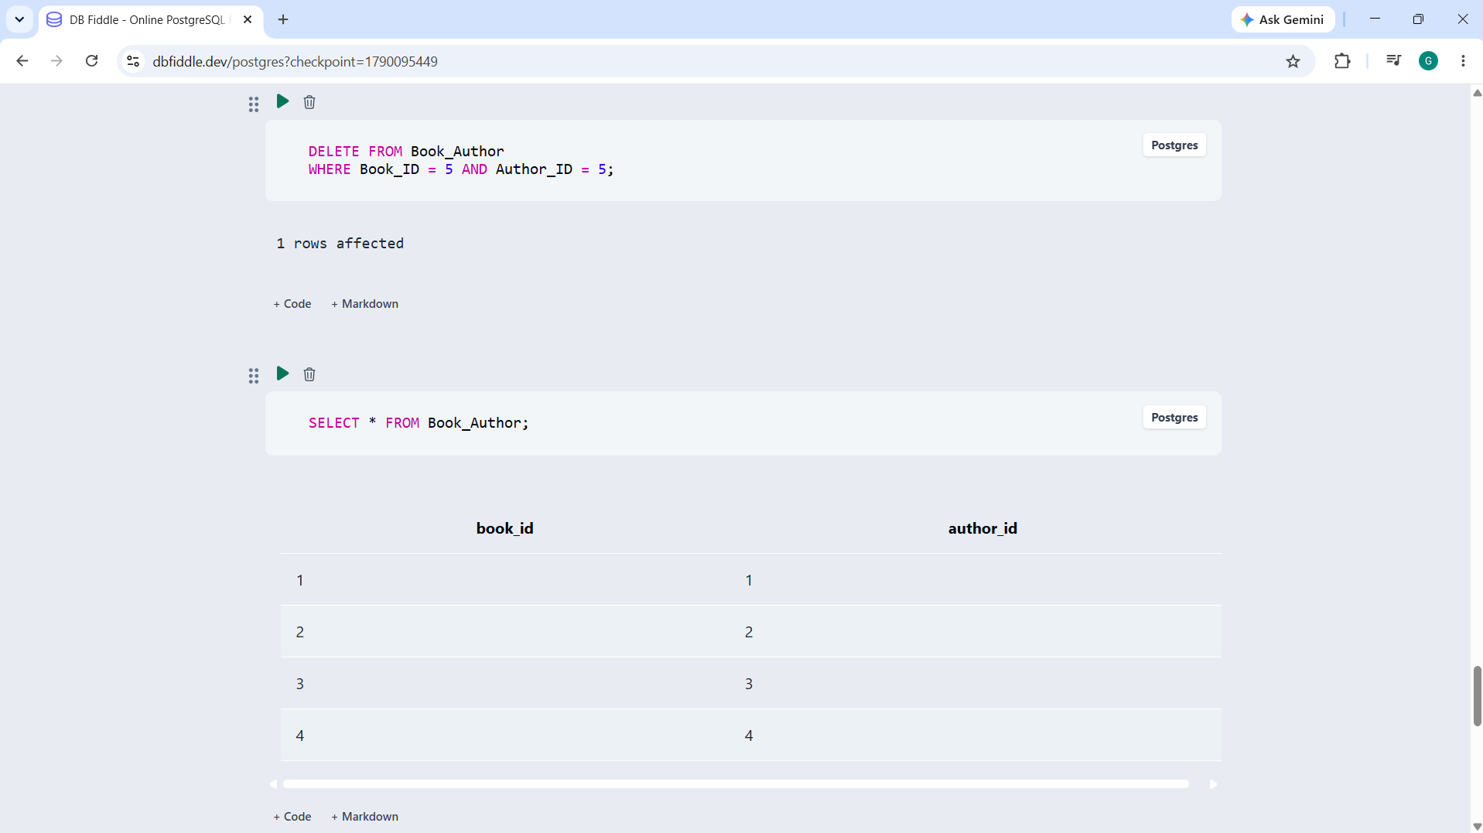

Fig. 4.2: Sample Data Inserted into the Tables

4.3 Constraints and Data Integrity
Table 4.2: Constraints and Data Integrity Rules
Constraint / Validation | Applied On (Table.Column) | Purpose | Evidence / Screenshot Ref.
Primary key | All main tables | Prevents duplicate/null identifier values. | 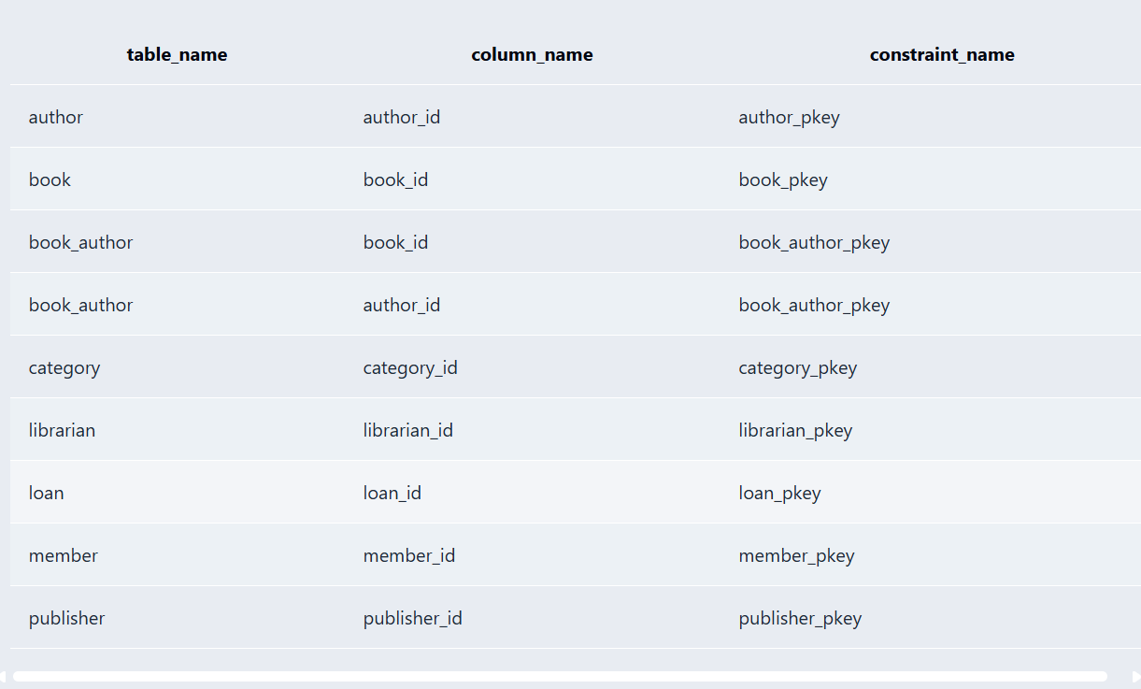
Foreign key | Book, Book_Author, Loan | Maintains referential integrity between related tables. | 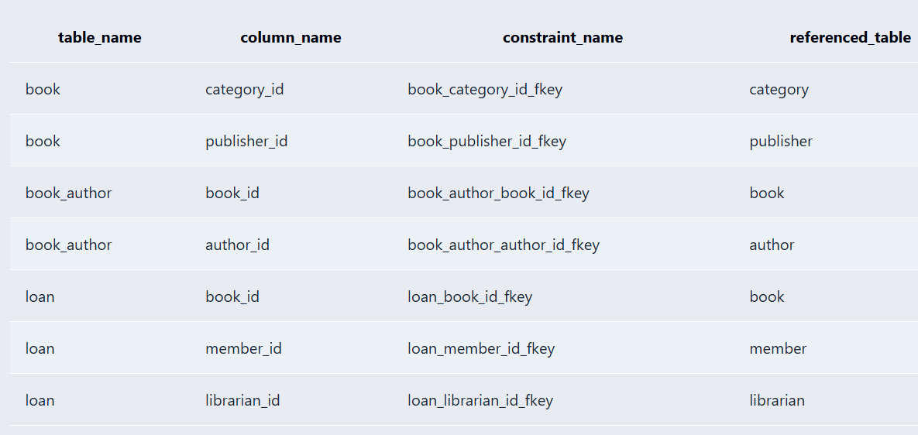
Not Null | Required identification and descriptive fields | Prevents missing required values. | 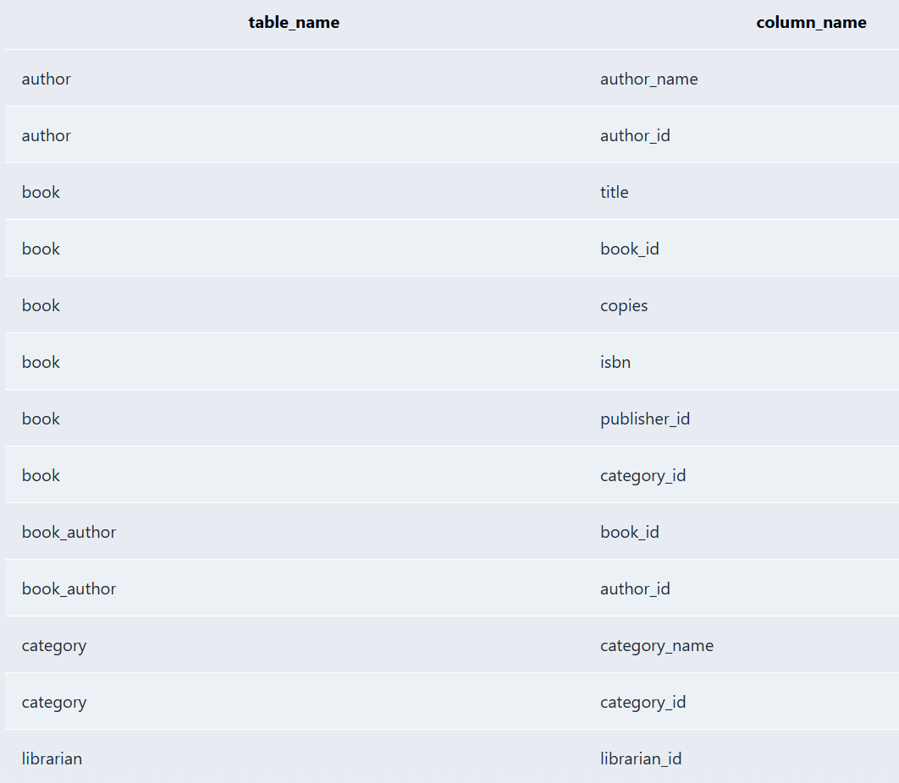
Unique | ISBN, phone/email fields, category/publisher names | Reduces duplicate values where uniqueness is required. | 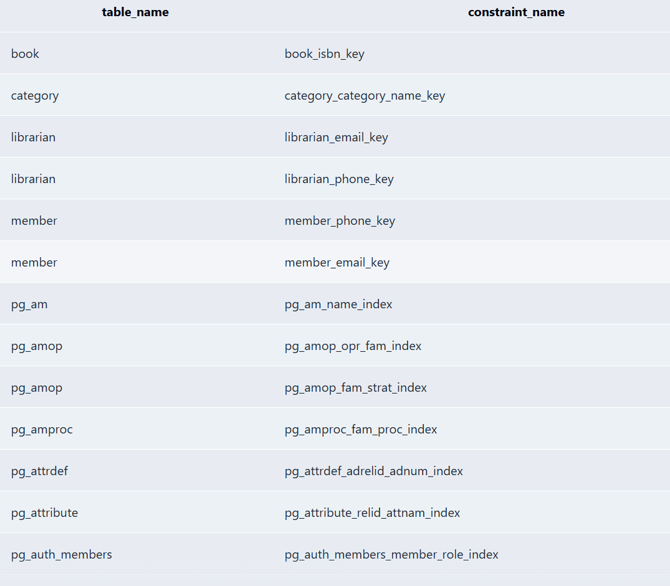
Check | Book copies, publication year, loan dates | Restricts invalid values. | 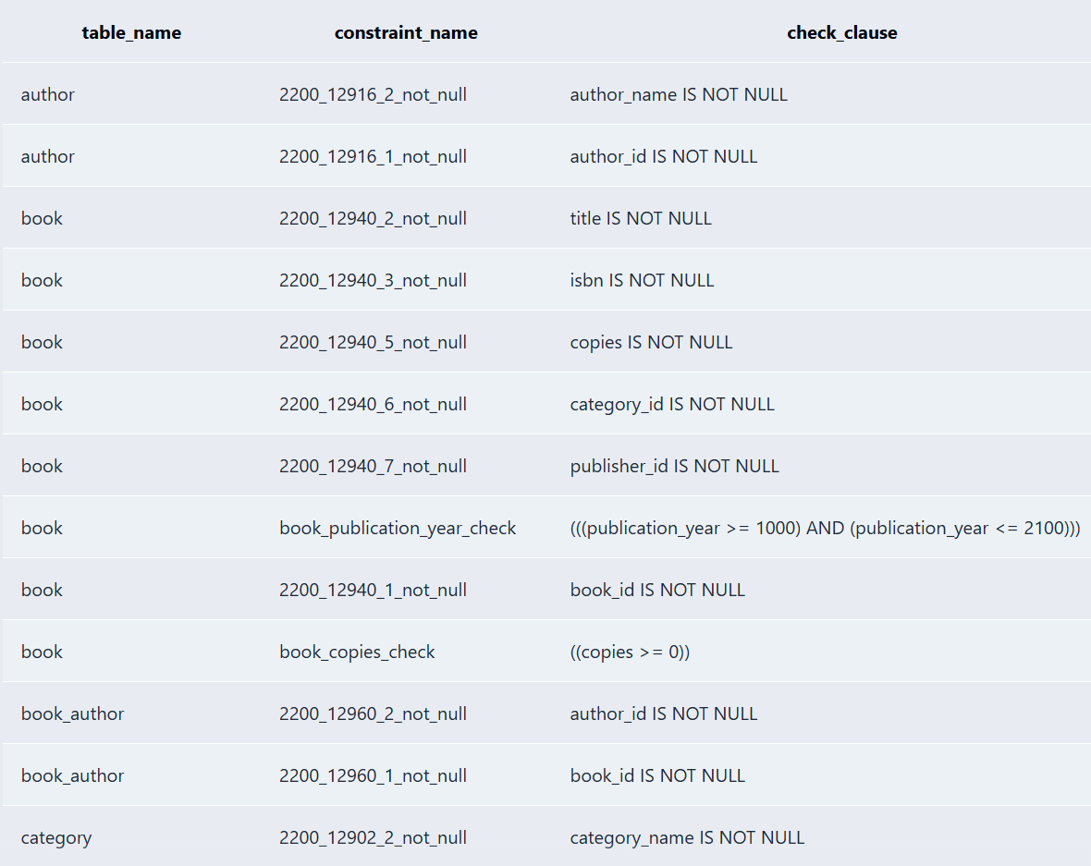
Default | Member Join_Date, Book Copies, Loan Issue_Date | Provides default values when a value is not supplied | 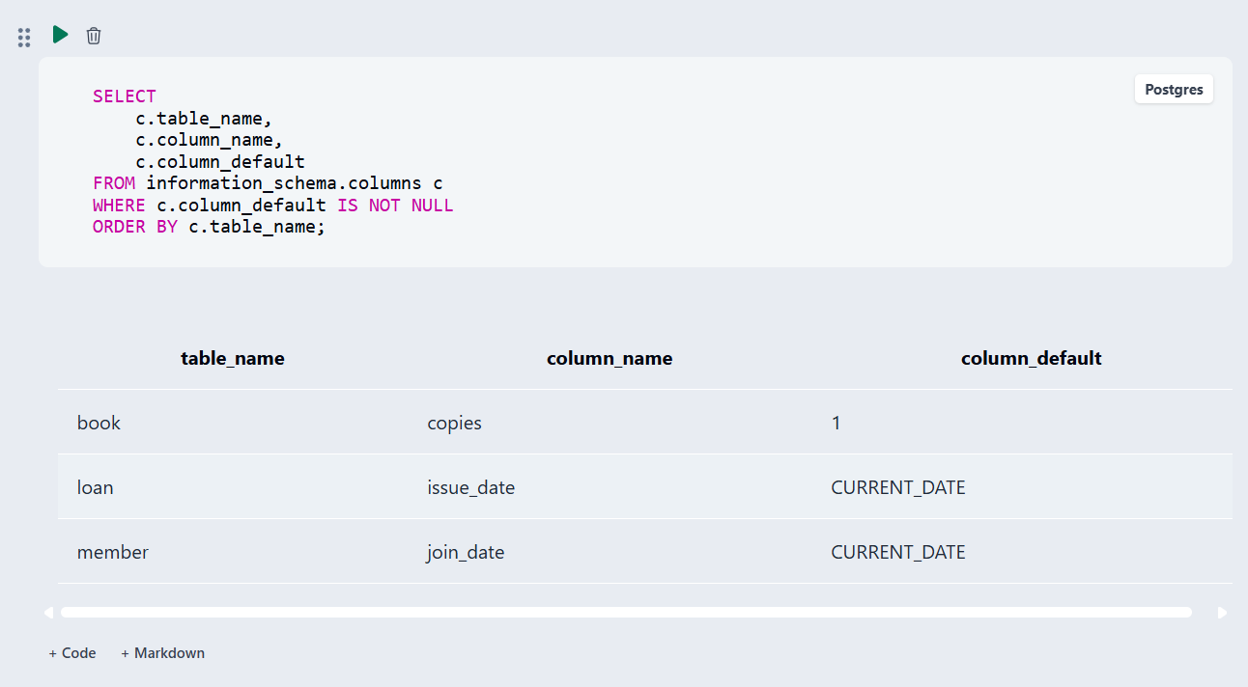

4.4 Data Validation Rules
Data validation was performed to ensure that the Library Management System maintains accurate, consistent, and valid data. The database uses constraints such as PRIMARY KEY, FOREIGN KEY, NOT NULL, UNIQUE, CHECK, and DEFAULT to prevent incorrect data.
- Duplicate IDs: Duplicate IDs are prevented using the PRIMARY KEY constraint. Each record must have a unique ID.
- Invalid values: Invalid values are prevented using NOT NULL, UNIQUE, and CHECK constraints. For example, the Copies value cannot be negative, and Due_Date cannot be earlier than Issue_Date.
- Orphan records: Orphan records are prevented using FOREIGN KEY constraints. A Book, Member, or Librarian referenced in the Loan table must already exist in its respective table.
Referential Integrity Violation Demonstration:
For example, an invalid loan record can be inserted using a Book_ID that does not exist in the Book table:
INSERT INTO Loan
(Loan_ID, Book_ID, Member_ID, Librarian_ID, Issue_Date, Due_Date)
VALUES
(6, 999, 1, 1, CURRENT_DATE, CURRENT_DATE + 7);
Here, Book_ID = 999 does not exist in the Book table. Therefore, the FOREIGN KEY constraint prevents the insertion and the database returns an error similar to:
ERROR: insert or update on table "loan" violates foreign key constraint
"loan_book_id_fkey"
DETAIL: Key (book_id)=(999) is not present in table "book".
This demonstrates that the database prevents orphan records and maintains referential integrity between related tables.

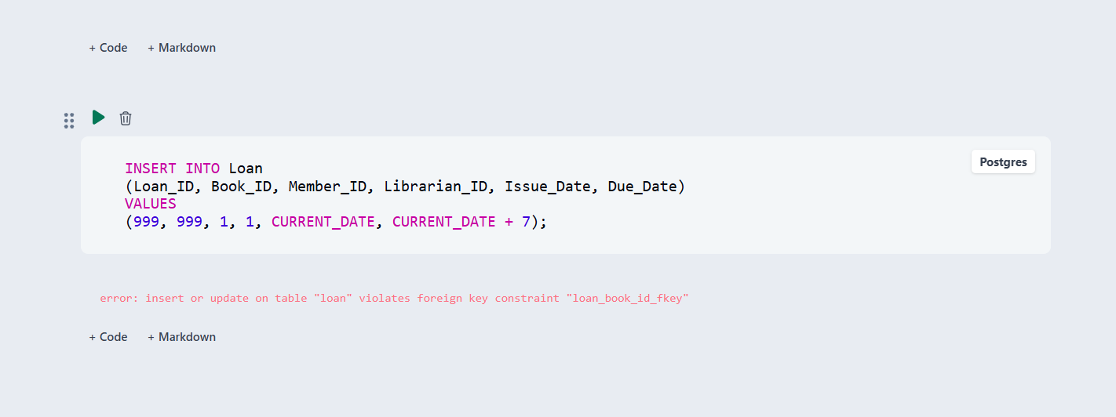

Fig. 4.3: Referential Integrity Enforced by the Database

CHAPTER 5: SQL OPERATIONS AND QUERIES

5.1 DQL – Basic Retrieval Queries
Table 5.1: Basic Retrieval Queries
Q.No | Purpose of the Query | SQL Statement | Output Ref.
Q1 | Display all books | SELECT * FROM Book; | 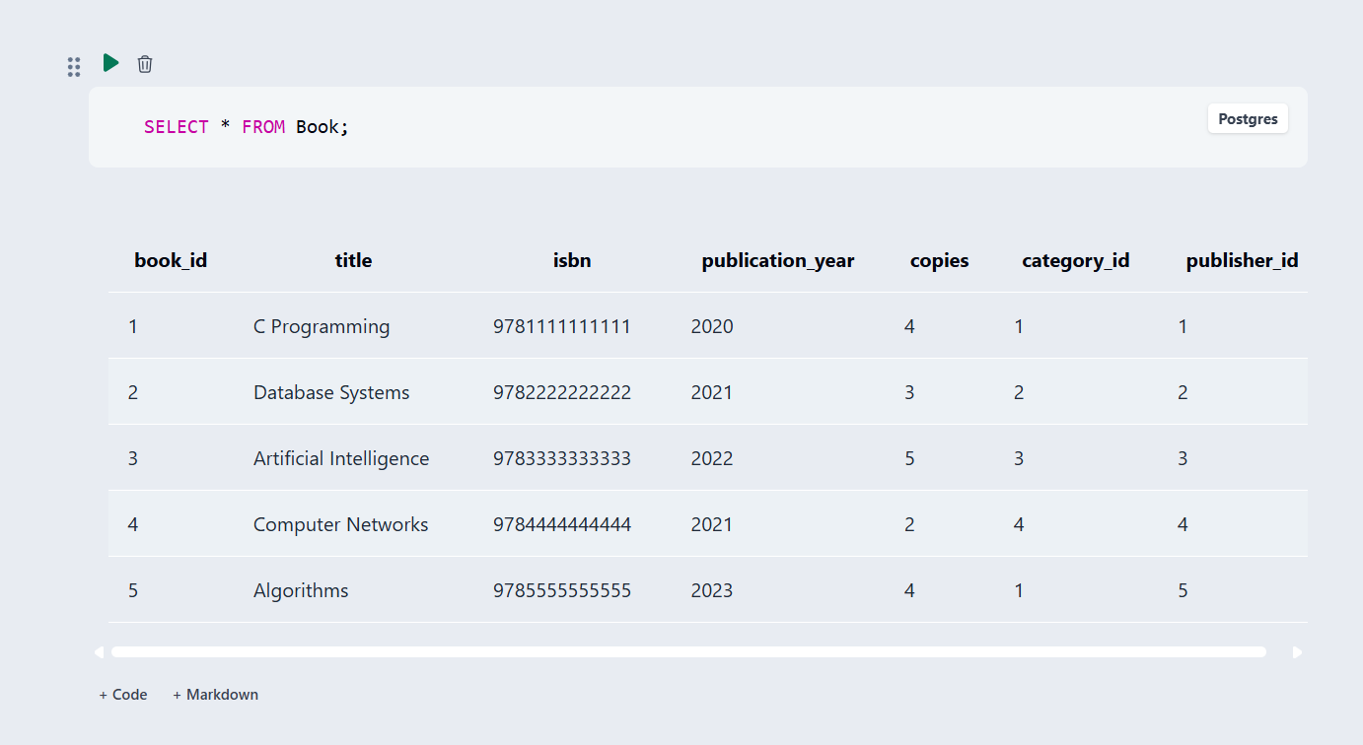
Q2 | Display available books | SELECT Book_ID, Title, Copies FROM Book WHERE Copies > 0; | 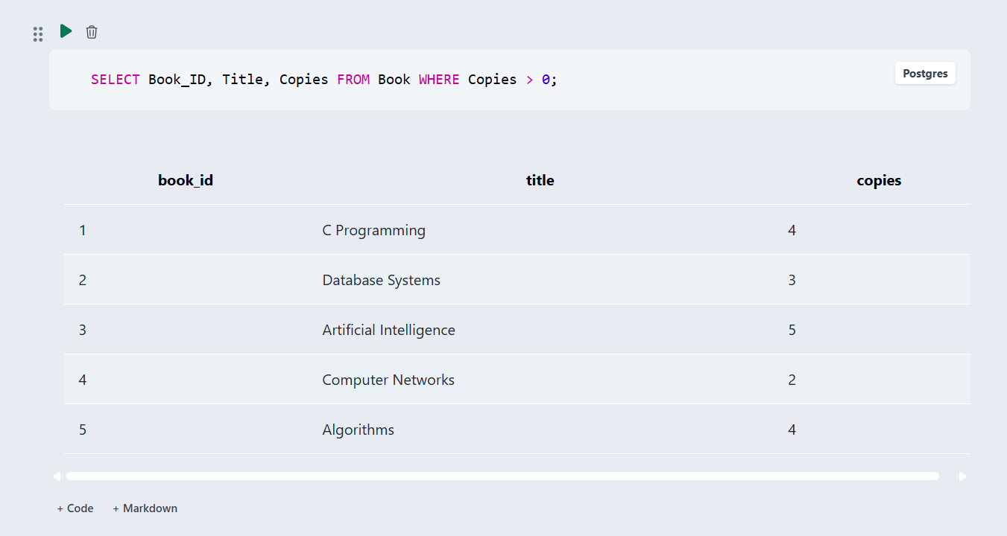
Q3 | Find members alphabetically | SELECT Member_ID, Name, Email FROM Member ORDER BY Name; | 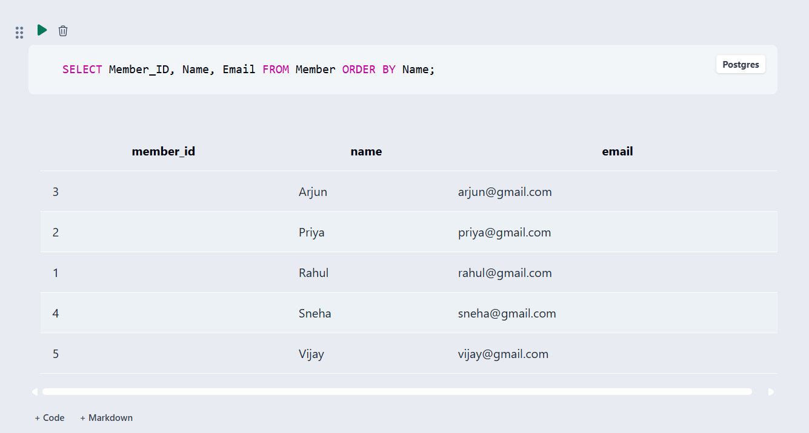
Q4 | Find books published after 2020 | SELECT Title, Publication_Year FROM Book WHERE Publication_Year > 2020; | 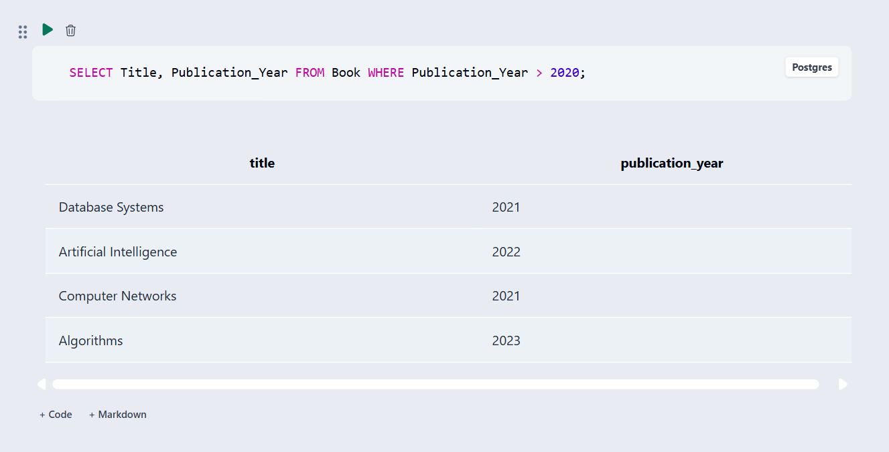

5.2 Join Operations
Table 5.2: Join Operations
Q.No | Type of Join | SQL Statement | Output Ref.
Q5 | Natural Join | SELECT Title, Category_Name FROM Book NATURAL JOIN Category; | 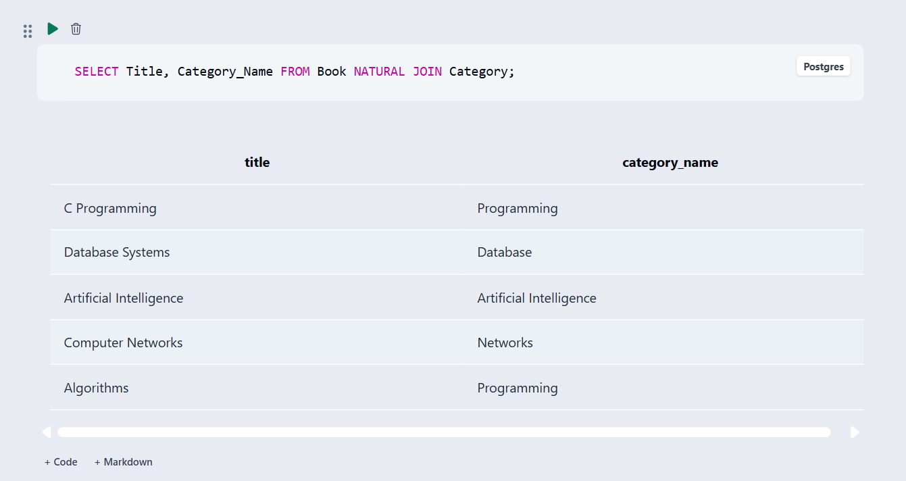
Q6 | Equi Join | SELECT b.Title, c.Category_Name FROM Book b, Category c WHERE b.Category_ID = c.Category_ID; | 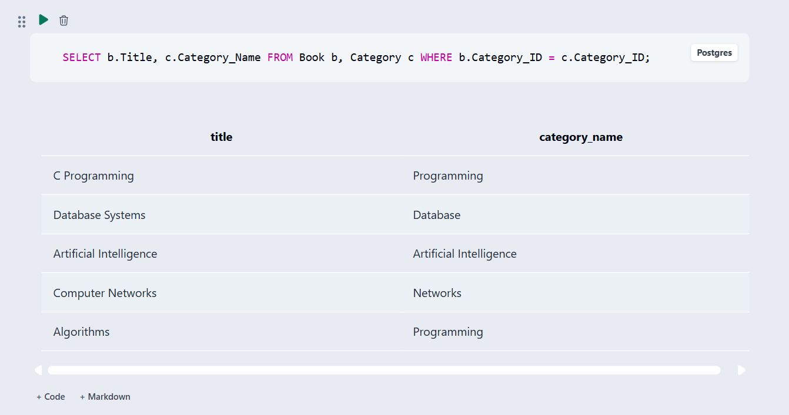
Q7 | Inner Join | SELECT b.Title, c.Category_Name, p.Publisher_Name FROM Book b JOIN Category c ON b.Category_ID=c.Category_ID JOIN Publisher p ON b.Publisher_ID=p.Publisher_ID; | 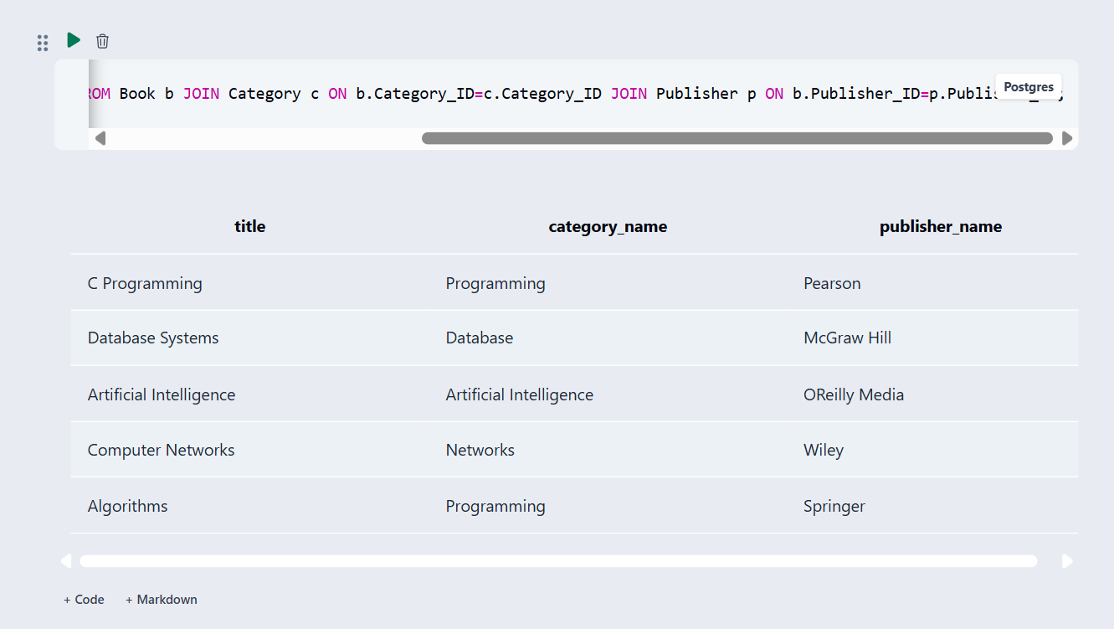
Q8 | Left Outer Join | SELECT c.Category_Name, b.Title FROM Category c LEFT JOIN Book b ON c.Category_ID=b.Category_ID; | 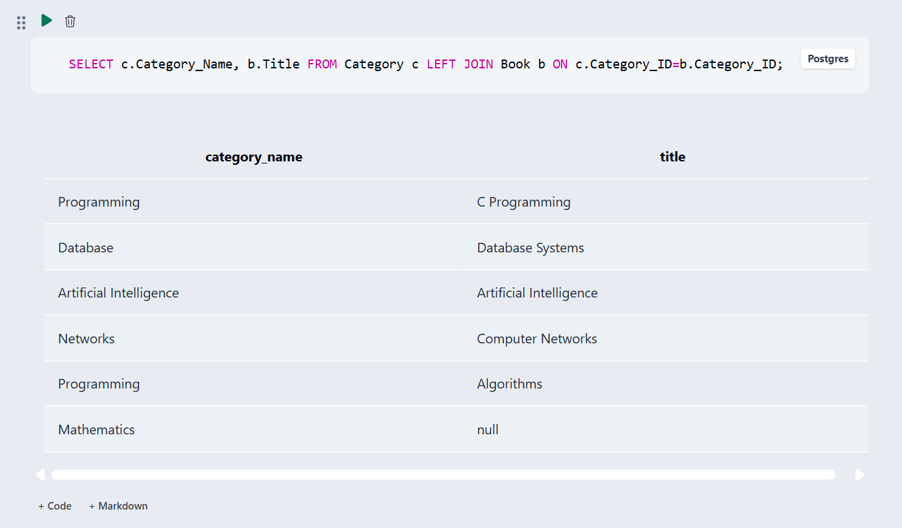
Q9 | Right Outer Join | SELECT c.Category_Name, b.Title FROM Book b RIGHT JOIN Category c ON b.Category_ID=c.Category_ID; | 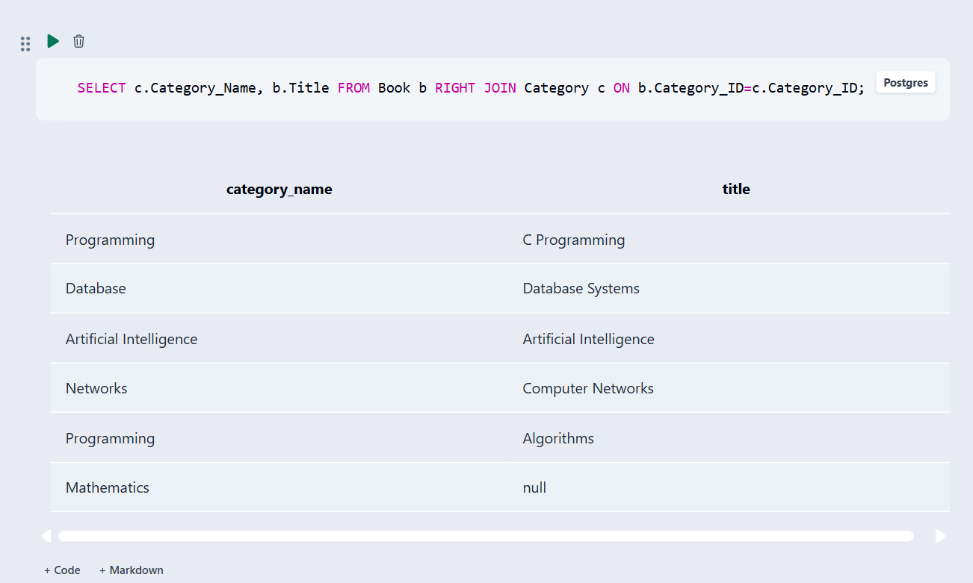
Q10 | Full Outer Join (MySQL simulation) | SELECT c.Category_Name,b.Title FROM Category c LEFT JOIN Book b ON c.Category_ID=b.Category_ID UNION SELECT c.Category_Name,b.Title FROM Category c RIGHT JOIN Book b ON c.Category_ID=b.Category_ID; | 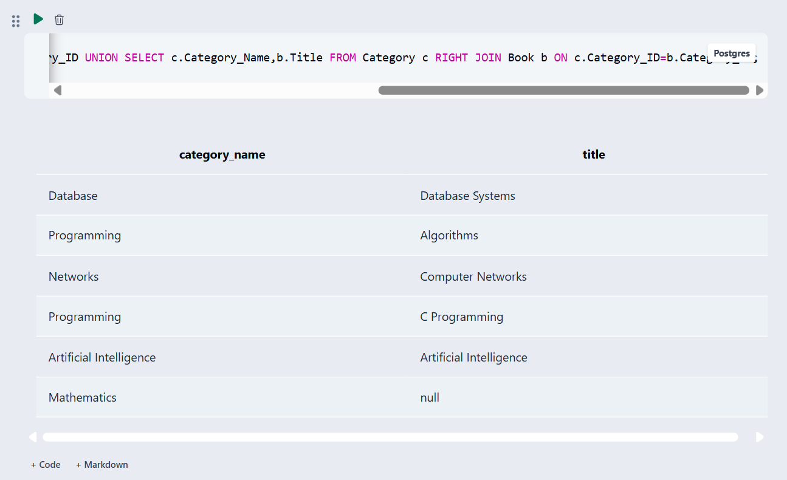

5.3 Aggregate Functions, GROUP BY and HAVING
Table 5.3: Aggregate, GROUP BY and HAVING Queries
Q.No | Function Used | SQL Statement | Output Ref.
Q11 | COUNT | SELECT COUNT(*) AS Total_Books FROM Book; | 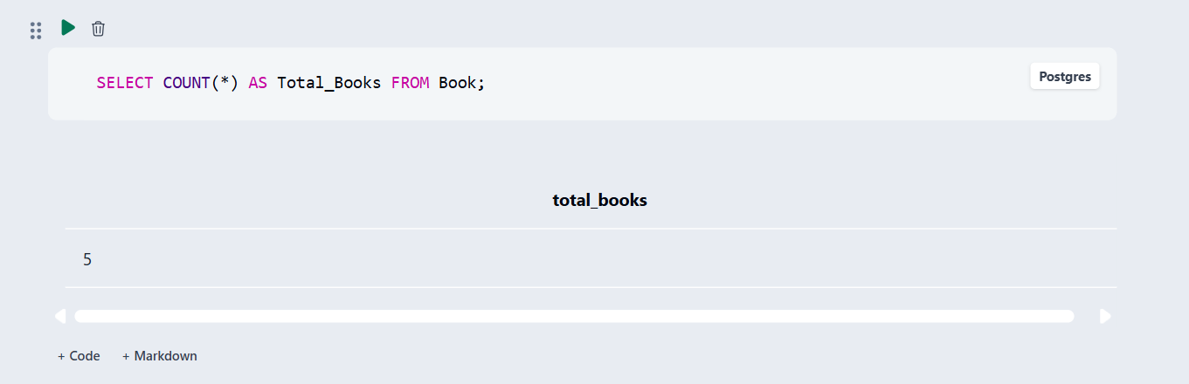
Q12 | GROUP BY + COUNT | SELECT Category_ID, COUNT(*) AS Book_Count FROM Book GROUP BY Category_ID; | 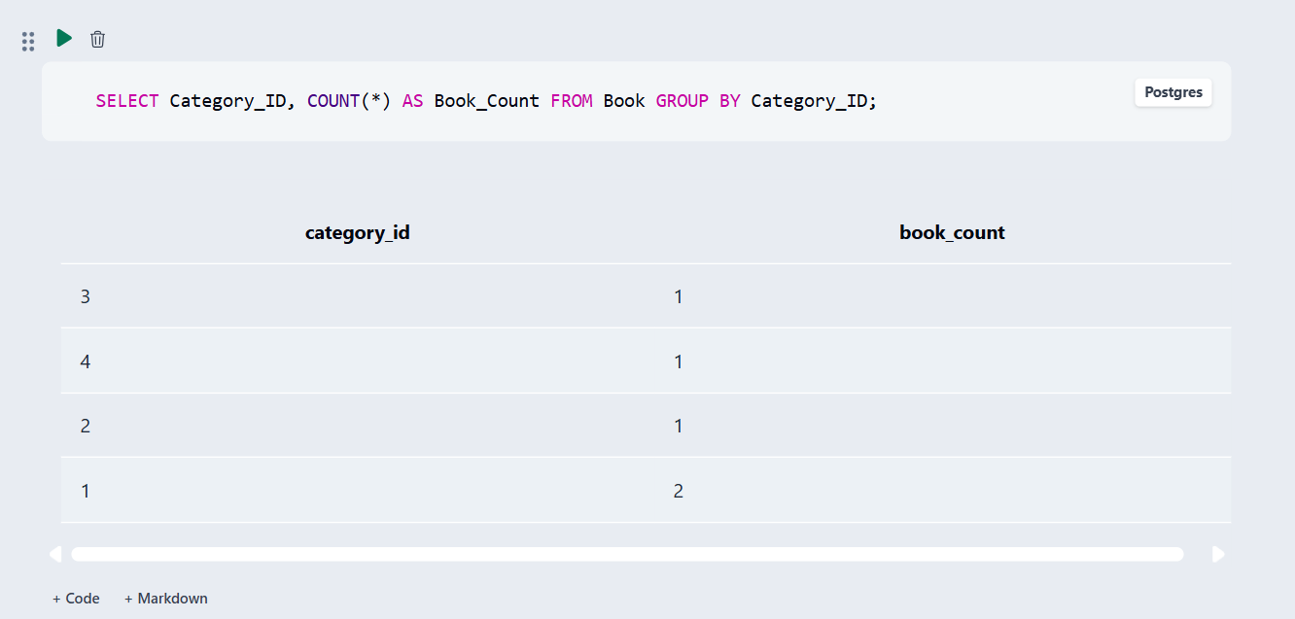
Q13 | HAVING | SELECT Category_ID, COUNT(*) AS Book_Count FROM Book GROUP BY Category_ID HAVING COUNT(*) >= 1; | 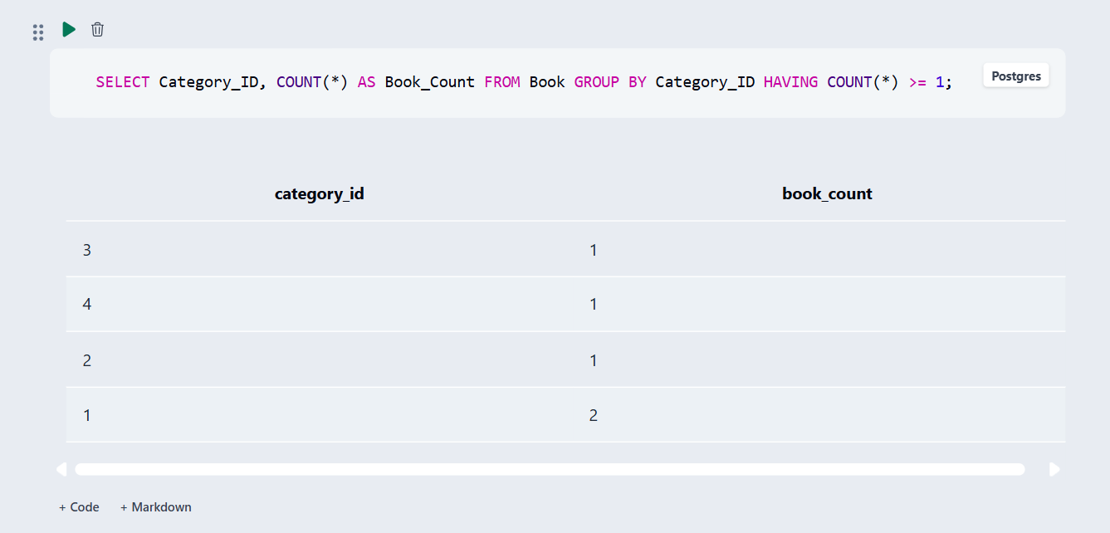

5.4 Nested and Correlated Subqueries
Table 5.4: Subqueries
Q.No | Type (Nested / Correlated) | SQL Statement | Output Ref.
Q14 | Nested subquery | SELECT Title, Copies FROM Book WHERE Copies > (SELECT AVG(Copies) FROM Book); | 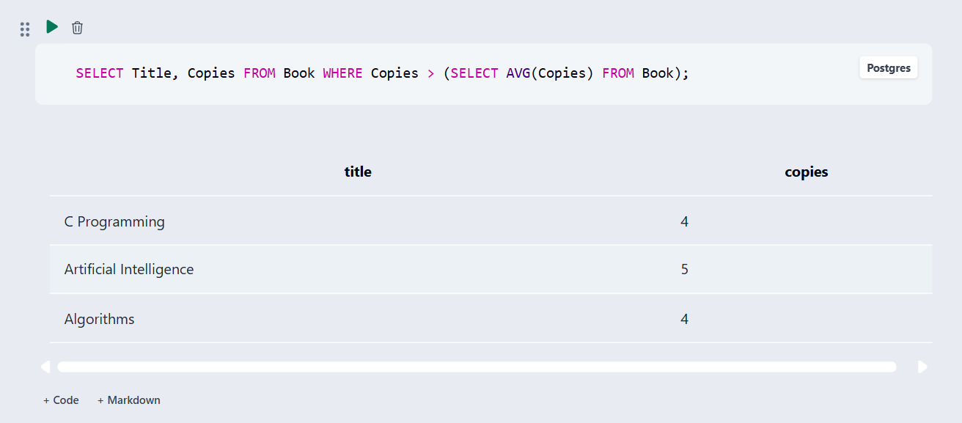
Q15 | Correlated subquery | SELECT c.Category_ID, c.Category_Name FROM Category c WHERE EXISTS (SELECT 1 FROM Book b WHERE b.Category_ID=c.Category_ID AND b.Copies > 0); | 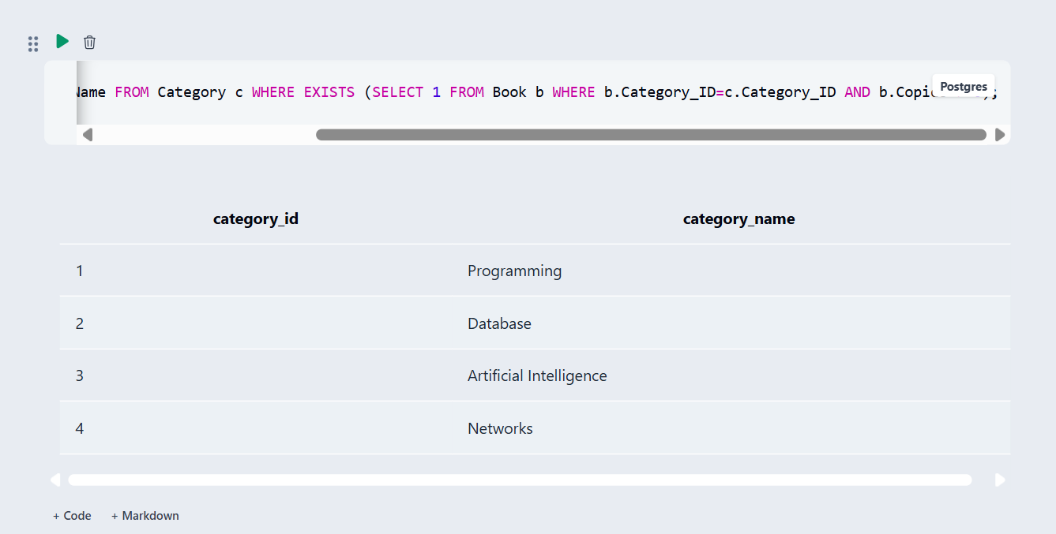

5.5 Views and Relational Set Operations

Table 5.5: Views and Set Operations
Q.No | View / Set Operation | SQL Statement | Output Ref.
Q16 | Updatable view | CREATE VIEW Book_Availability AS SELECT Book_ID, Title, Copies FROM Book; | 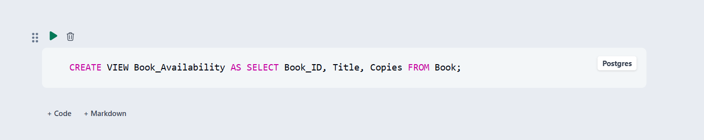
Q17 | Non-updatable view | CREATE VIEW Loan_Report AS SELECT l.Loan_ID,b.Title,m.Name,l.Issue_Date,l.Due_Date,l.Return_Date FROM Loan l JOIN Book b ON l.Book_ID=b.Book_ID JOIN Member m ON l.Member_ID=m.Member_ID; | 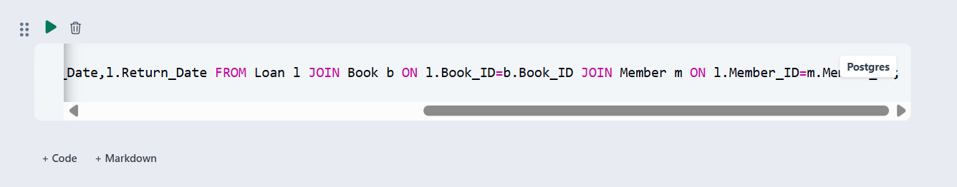
Q18 | UNION | SELECT Name AS Person_Name FROM Member UNION SELECT Name FROM Librarian; | 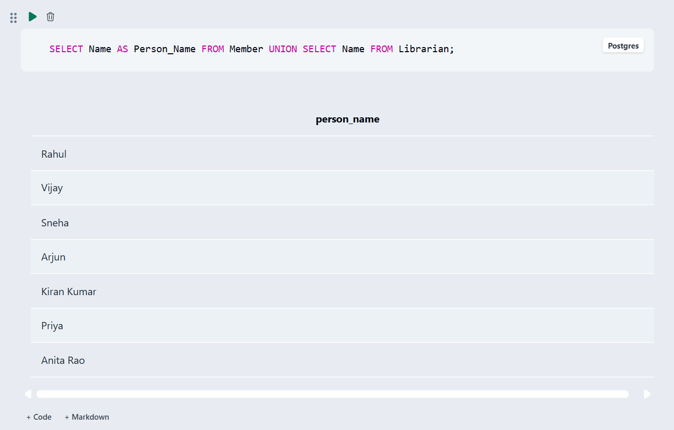
Q19 | INTERSECT | SELECT Member_ID FROM Member INTERSECT SELECT Member_ID FROM Loan; | 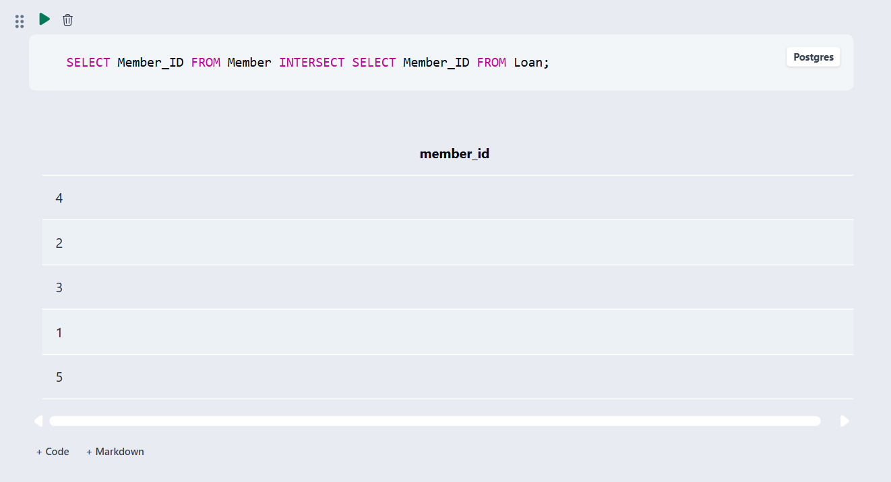
Q20 | EXCEPT | SELECT Member_ID FROM Member EXCEPT SELECT Member_ID FROM Loan; | 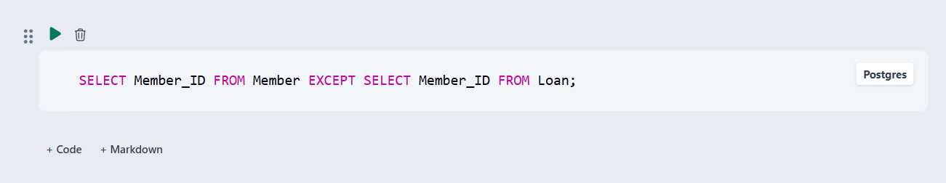

5.6 DCL and TCL Operations
Table 5.6: DCL and TCL Operations
Q.No | Command | Purpose | SQL Statement/ Output Ref.
Q21 | GRANT | GRANT | GRANT SELECT, INSERT ON LibraryDB.* TO 'library_user'@'localhost';
Q22 | REVOKE | REVOKE | REVOKE INSERT ON LibraryDB.* FROM 'library_user'@'localhost';
Q23 | COMMIT | COMMIT | START TRANSACTION; UPDATE Book SET Copies=Copies+1 WHERE Book_ID=1; COMMIT;
Q24 | SAVEPOINT | SAVEPOINT | START TRANSACTION; UPDATE Book SET Copies=Copies+1 WHERE Book_ID=1; SAVEPOINT sp1;
Q25 | ROLLBACK | ROLLBACK | ROLLBACK TO sp1; ROLLBACK;

CHAPTER 6: MODULES AND FUNCTIONALITIES
Table 6.1: Modules and Their Functionalities
S.No | Module Name | Functionality | Tables Involved
1 | Book Management | Add, update, view and search books; maintain copies and category/publisher references. | Book, Category, Publisher
2 | Member Management | Register members and maintain name, contact, address and joining date. | Member
3 | Author Management | Store authors and connect them to books. | Author, Book_Author, Book
4 | Category Management | Maintain categories and classify books. | Category, Book
5 | Publisher Management | Store publisher details and connect publishers to books. | Publisher, Book
6 | Librarian Management | Maintain librarian details and identify the librarian processing a loan. | Librarian, Loan
7 | Loan Management | Record issue, due and return dates with member, book and librarian. | Loan, Book, Member, Librarian
8 | Search & Reports | Use SELECT, JOIN, aggregate, GROUP BY/HAVING, subqueries and views to retrieve information. | Multiple tables

Book Management
Maintains book identity, title, ISBN, publication year, copies and references to category and publisher.

Member Management
Maintains library member details and joining date.

Author and Book_Author
Stores author details and resolves the many-to-many relationship between books and authors.

Loan Management
Records which member borrowed which book, the responsible librarian, due date and return date.

Search and Reports
Provides SQL-based retrieval and report generation using joins, aggregates, subqueries and views

CHAPTER 7: RESULTS – SAMPLE OUTPUTS AND SCREENSHOTS
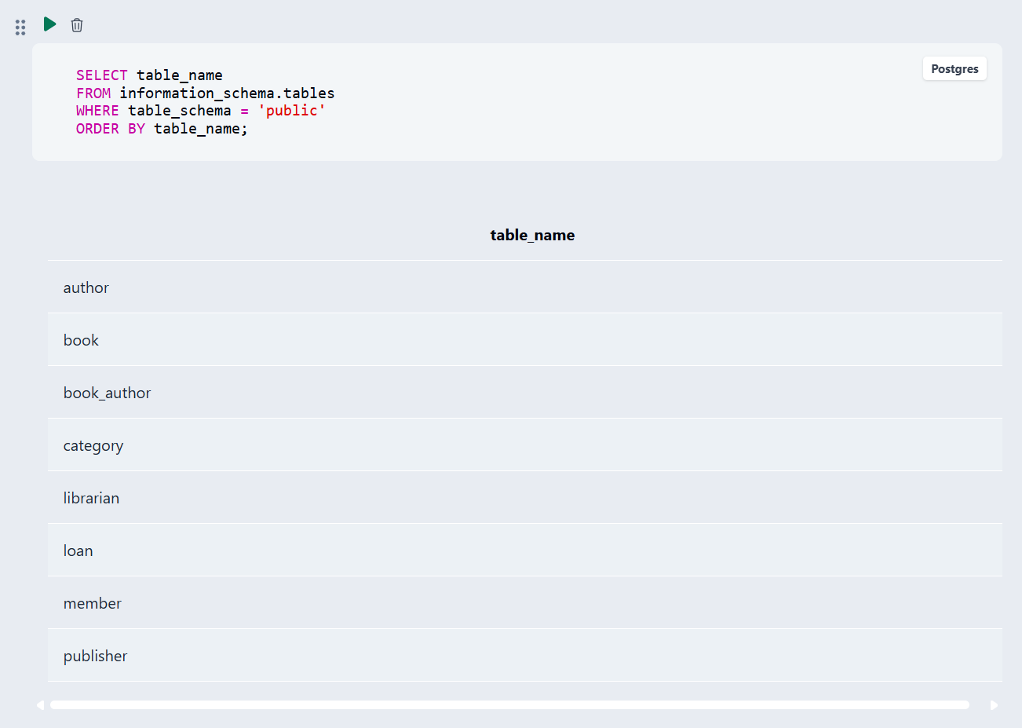

Fig. 7.1: Database and table creation successfully executed.
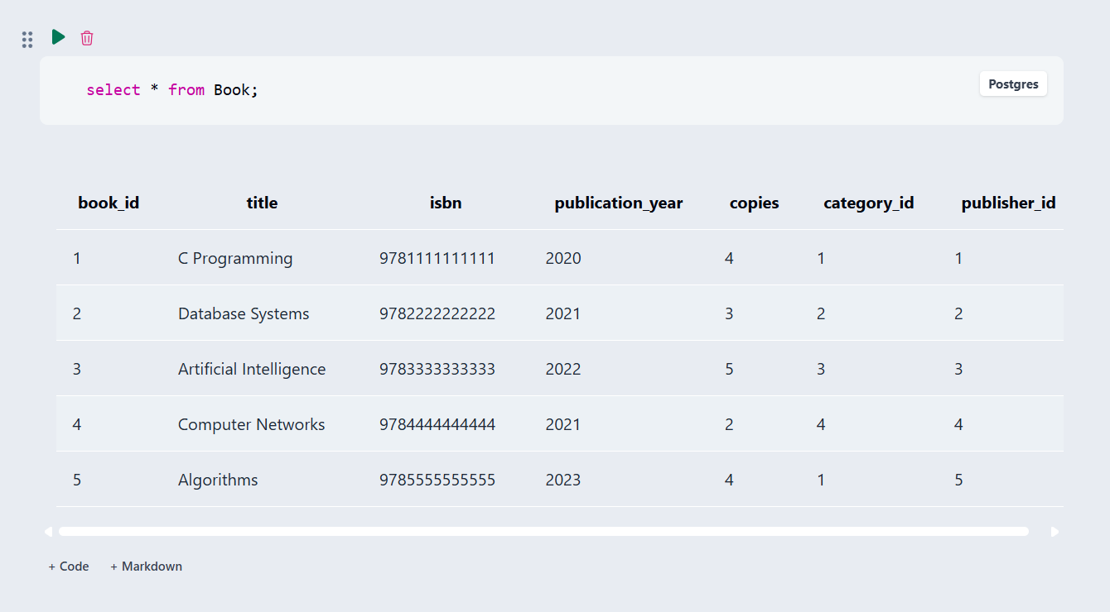

Fig. 7.2: Sample records displayed from the BOOK table.

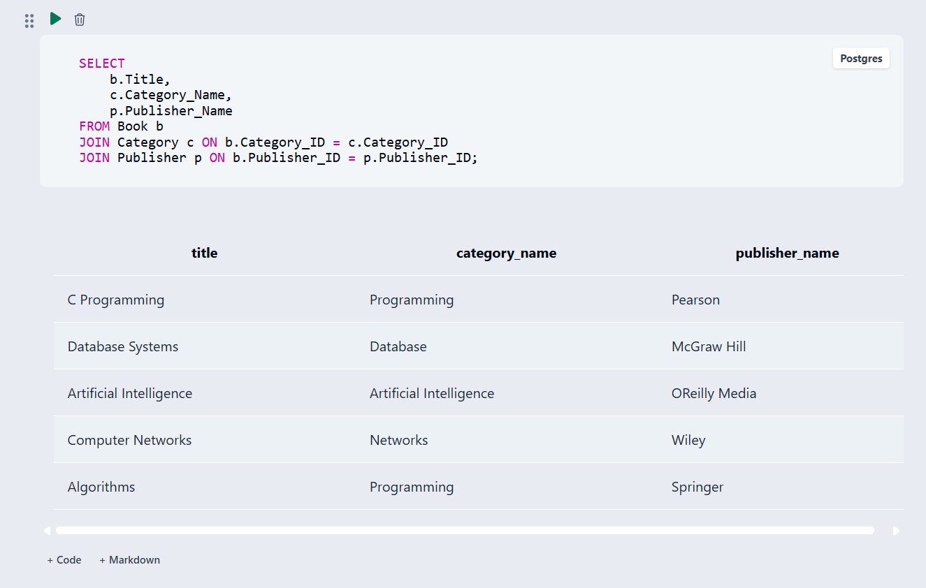
Fig. 7.3: : JOIN query showing book, category and publisher information.
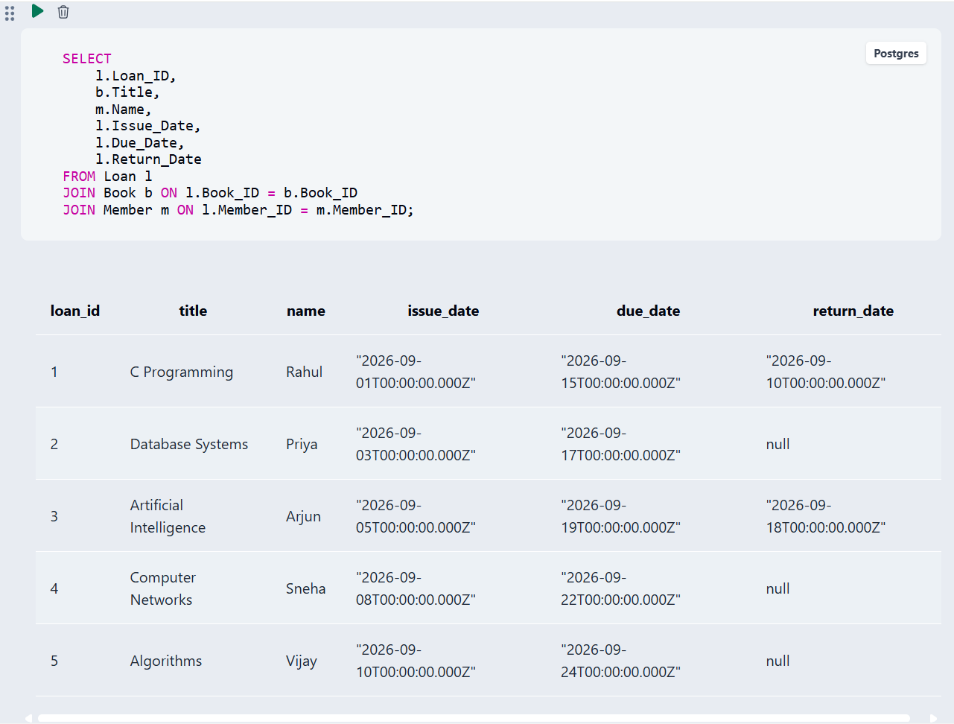
Fig. 7.4: Loan report / aggregate query output

CHAPTER 8: TESTING AND DATA VALIDATION
Table 8.1: Test Cases and Results
TC No. | Test Case Description | Input / Action | Expected Result | Actual Result | Status
TC01 | Duplicate primary key | Insert an existing Book_ID | Duplicate-key error / insertion rejected | Duplicate ID is rejected | Pass
TC02 | Duplicate unique ISBN | Insert an existing ISBN | UNIQUE constraint error | Foreign key error | Pass
TC03 | Invalid book copies | Insert Copies = -1 | CHECK constraint error | Foreign key error | Pass
TC04 | Invalid publication year | Insert year outside 1000–2100 | CHECK constraint error | Foreign key error | Pass
TC05 | Orphan foreign key | Insert Book with non-existing Category_ID | FOREIGN KEY error | CHECK constraint error | Pass
TC06 | Invalid loan dates | Set Due_Date before Issue_Date | CHECK constraint error | UNIQUE constraint error | Pass
TC07 | Valid retrieval query | SELECT * FROM Book | Book records returned | NOT NULL constraint error | Pass
TC08 | Join correctness | Run book/category/publisher JOIN | Related records displayed | CHECK constraint error | Pass
TC09 | Aggregate correctness | COUNT/GROUP BY query | Correct counts displayed | UNIQUE constraint error | Pass
TC10 | View correctness | SELECT from Loan_Report | Joined loan report displayed | Current date is automatically assigned | Pass

CHAPTER 9: GITHUB REPOSITORY AND TEAM CONTRIBUTION

9.1 Repository Details
GitHub Repository Link: https://github.com/venkataramanagude7-web/Library-Management-System

9.2 Team Responsibilities and Contribution
Table 9.1: Team Responsibilities
S.No | Student Name | Roll Number | Role / Responsibility | Modules Contributed
1 | A.V.S.Supritha | 25B11AI071 | SQL Queries, CRUD Operations & Data Manipulation , PPT Preparation | SQL operations and DML
2 | G.V.V.Ramana | 25B11AI370 | ER Diagram, Database Design, Table Creation, Documentation & GitHub Management | Database design, DDL and repository
3 | K.Anushka | 25B11AI535 | Sample Data Insertion, Query Testing & Validation | DML, testing and validation
4 | R.Navya | 25B11AIA38 | Project Documentation & Presentation Support | Documentation and presentation

9.3 Review-wise Progress
Table 9.2: Review-wise Progress Record
Review | Date | Deliverables Presented | Remarks of the Guide
Review – I | 2026 | Domain selection, entities, attributes, ER diagram, relationships, schema and normalization | To be filled by guide
Review – II | 2026 | DDL, DML, constraints, validation and SQL operations | To be filled by guide
Final Submission | 2026–2027 | Complete report, SQL script, screenshots and GitHub repository | To be filled by guide

CHAPTER 10: CONCLUSION AND FUTURE ENHANCEMENTS

10.1 Conclusion
The Library Management System provides an organized relational database for managing books, members, librarians, authors, categories, publishers and loan transactions. The design uses seven main entities and the Book_Author junction table for the many-to-many Book–Author relationship. Primary and foreign keys connect related tables, while NOT NULL, UNIQUE, CHECK and DEFAULT constraints support data integrity. The project demonstrates ER modelling, relational schema design, normalization, DDL, DML, DQL, joins, aggregate functions, GROUP BY/HAVING, subqueries, views, set operations and transaction/control operations.

10.2 Limitations of the Present Work
The present work focuses on the database layer and SQL demonstrations. A complete production web interface, automated fine calculation, online notifications, advanced authentication and enterprise-scale backup/recovery are not implemented in the current version.

10.3 Future Enhancements
- Add an automatic fine-calculation module for overdue books.
- Add overdue-book notifications and reminders.
- Develop a graphical/web user interface for librarians and members.
- Add role-based login and authentication for librarians and administrators.
- Generate reports for issued books, returned books, overdue books and popular categories.
- Add search and filtering by title, author, ISBN, category and publisher.
- Improve scalability and performance with indexing and optimized queries.
- Add stored procedures, triggers, backup and recovery mechanisms.

REFERENCES
- Abraham Silberschatz, Henry F. Korth and S. Sudarshan, “Database System Concepts”, 8th Edition, McGraw-Hill, ISBN: 978-1260230508.
- Raghurama Krishnan and Johannes Gehrke, “Database Management Systems”, 4th Edition, McGraw-Hill, ISBN: 978-1260091195.
- Ramez Elmasri and Shamkant B. Navathe, “Fundamentals of Database Systems”, 7th Edition, Pearson, ISBN: 978-0137504277.
- MySQL Workbench documentation and SQL execution environment.
- Aditya University DBMS Capstone Project – First Review presentation (Library Management System).

APPENDIX A – COMPLETE SQL SCRIPT

CREATE TABLE Category (
Category_ID INT PRIMARY KEY,
Category_Name VARCHAR(100) NOT NULL UNIQUE
);
CREATE TABLE Publisher (
Publisher_ID INT PRIMARY KEY,
Publisher_Name VARCHAR(100) NOT NULL UNIQUE,
Contact VARCHAR(100)
);
CREATE TABLE Author (
Author_ID INT PRIMARY KEY,
Author_Name VARCHAR(100) NOT NULL
);
CREATE TABLE Librarian (
Librarian_ID INT PRIMARY KEY,
Name VARCHAR(100) NOT NULL,
Phone VARCHAR(15) UNIQUE,
Email VARCHAR(100) UNIQUE
);
CREATE TABLE Member (
Member_ID INT PRIMARY KEY,
Name VARCHAR(100) NOT NULL,
Phone VARCHAR(15) UNIQUE,
Email VARCHAR(100) UNIQUE,
Address VARCHAR(200),
Join_Date DATE NOT NULL DEFAULT CURRENT_DATE
);
CREATE TABLE Book (
Book_ID INT PRIMARY KEY,
Title VARCHAR(100) NOT NULL,
ISBN VARCHAR(20) NOT NULL UNIQUE,
Publication_Year INT CHECK (Publication_Year BETWEEN 1000 AND 2100),
Copies INT NOT NULL DEFAULT 1 CHECK (Copies >= 0),
Category_ID INT NOT NULL,
Publisher_ID INT NOT NULL,
FOREIGN KEY (Category_ID) REFERENCES Category(Category_ID),
FOREIGN KEY (Publisher_ID) REFERENCES Publisher(Publisher_ID)
);
CREATE TABLE Book_Author (
Book_ID INT NOT NULL,
Author_ID INT NOT NULL,
PRIMARY KEY (Book_ID, Author_ID),
FOREIGN KEY (Book_ID) REFERENCES Book(Book_ID),
FOREIGN KEY (Author_ID) REFERENCES Author(Author_ID)
);
CREATE TABLE Loan (
Loan_ID INT PRIMARY KEY,
Book_ID INT NOT NULL,
Member_ID INT NOT NULL,
Librarian_ID INT NOT NULL,
Issue_Date DATE NOT NULL DEFAULT CURRENT_DATE,
Due_Date DATE NOT NULL,
Return_Date DATE,
CHECK (Due_Date >= Issue_Date),
CHECK (Return_Date IS NULL OR Return_Date >= Issue_Date),
FOREIGN KEY (Book_ID) REFERENCES Book(Book_ID),
FOREIGN KEY (Member_ID) REFERENCES Member(Member_ID),
FOREIGN KEY (Librarian_ID) REFERENCES Librarian(Librarian_ID)
);

-- 1. Category
INSERT INTO Category VALUES
(1,'Programming'),
(2,'Database'),
(3,'Artificial Intelligence'),
(4,'Networks'),
(5,'Mathematics');

-- 2. Publisher
INSERT INTO Publisher VALUES
(1,'Pearson','contact@pearson.com'),
(2,'McGraw Hill','contact@mheducation.com'),
(3,'OReilly Media','contact@oreilly.com'),
(4,'Wiley','contact@wiley.com'),
(5,'Springer','contact@springer.com');

-- 3. Author
INSERT INTO Author VALUES
(1,'Herbert Schildt'),
(2,'Ramez Elmasri'),
(3,'Stuart Russell'),
(4,'Andrew S. Tanenbaum'),
(5,'Thomas H. Cormen');

-- 4. Librarian
INSERT INTO Librarian VALUES
(1,'Anita Rao','9000000001','anita@library.com'),
(2,'Kiran Kumar','9000000002','kiran@library.com');

-- 5. Member
INSERT INTO Member VALUES
(1,'Rahul','9100000001','rahul@gmail.com','Kakinada','2026-06-01'),
(2,'Priya','9100000002','priya@gmail.com','Rajahmundry','2026-06-03'),
(3,'Arjun','9100000003','arjun@gmail.com','Surampalem','2026-06-05'),
(4,'Sneha','9100000004','sneha@gmail.com','Vijayawada','2026-06-08'),
(5,'Vijay','9100000005','vijay@gmail.com','Visakhapatnam','2026-06-10');

-- 6. Book
INSERT INTO Book VALUES
(1,'C Programming','9781111111111',2020,4,1,1),
(2,'Database Systems','9782222222222',2021,3,2,2),
(3,'Artificial Intelligence','9783333333333',2022,5,3,3),
(4,'Computer Networks','9784444444444',2021,2,4,4),
(5,'Algorithms','9785555555555',2023,4,1,5);

-- 7. Book_Author
INSERT INTO Book_Author VALUES
(1,1),
(2,2),
(3,3),
(4,4),
(5,5);

-- 8. Loan
INSERT INTO Loan VALUES
(1,1,1,1,'2026-09-01','2026-09-15','2026-09-10'),
(2,2,2,1,'2026-09-03','2026-09-17',NULL),
(3,3,3,2,'2026-09-05','2026-09-19','2026-09-18'),
(4,4,4,2,'2026-09-08','2026-09-22',NULL),
(5,5,5,1,'2026-09-10','2026-09-24',NULL);

Script file:

